Celebrating the Journey of Faith Together:
A Guide to Your Role as a Catholic Godparent

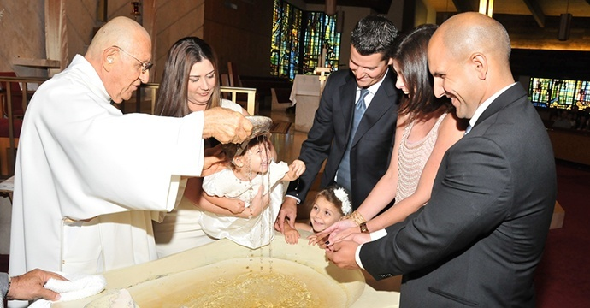

[SAMPLE FOR PARISH USE]

June 24, 2019

Dear Godparents,

Congratulations! You have been chosen to serve as a godparent, a duty crucial to the vitality of the Church. Your very life has evangelized others, growing their faith in the truth of Jesus Christ. Thank you for your commitment and witness to the Church.

On this Solemnity of the Nativity of John the Baptist, we recall that John was called to go before the Lord and prepare a way for Christ. You also are making room for others to see Christ more clearly.

This is the beginning of an exciting, life-long mentorship, walking alongside another person on their journey of faith. Included in this resource, I hope you find encouragement and support as you undertake this sacred responsibility. Be assured of my prayers for you as you minister to our growing Church in this way.

Sincerely in Christ,

[Pastor]

Prayer of the Godparent
God of light and love,
thank you for the joy of being a Godparent,
and the opportunities it gives us to journey with our godchild as they grow in faith.
Keep us faithful to the promises we have made to pray for them,
and to encourage them to deepen their relationship with you.
Help us to be a prayerful, supportive, and loving presence in the lives of our godchild,
and to model to them a life rooted in you:
the way, the truth, and the life.
Amen.

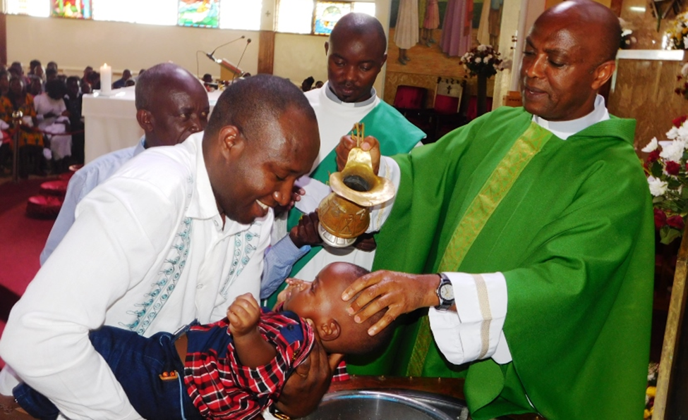
Baptism through the Eyes of a Godparent

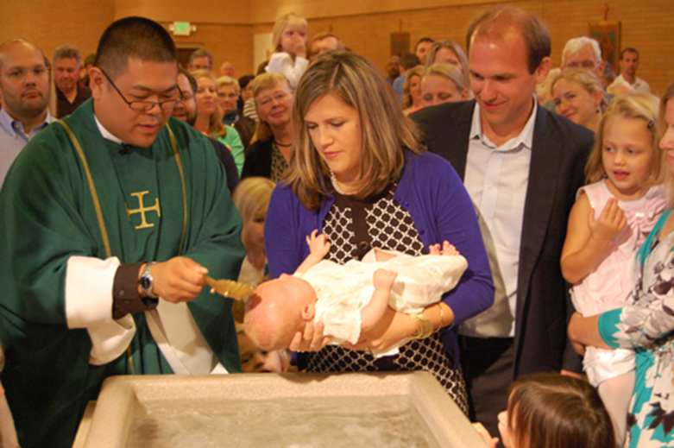
The dress was at least 150 years old, passed through several generations and countless cousins. The pure white faded to a more antique yellow, but Julia, my godchild, still beamed and giggled with delight, radiating love as she wore the family heirloom.
Today was her special day; her birthday into the Christian community. Some may say she had no idea what she was undertaking, but I think infants sense the important things—comfort, security, love. All these gifts would be hers in Jesus Christ on this day, no matter what else happened in her life. My role, as witness, was to remind her of this when she could no longer sense it with the potency of an infant.
I watched the community gathered, a few dismayed that Mass would go longer, but mostly pews filled with warm smiles at the sight of a little one all dressed up. Julia was already evangelizing her community, bringing their minds and hearts into focus about what truly matters. I could see shoulders relax and facial lines soften as the Mass began.
I was honored to stand with Julia, a true light, on that day, and to know that together with the community, we had a serious but exciting challenge ahead of us. Julia’s eyes watched the priest the entire time. She was held by Father during the homily, and she peacefully fell asleep, feeling the comfort of love in persona Christi. When it came time for the water ritual, the community was still in anticipation. Would she be a screamer? The holy water splashed across her forehead and she let out a coo and giggle as though she knew she was liberated from sin.
I wish she could remember the joy of this day. Her pastor, her parents, her aunts and uncles all laughed, enjoying one another’s company and the excuse to see each other. It was a day of pure joy and true blessing!

“A Christian is never bored or sad. Rather, the one who loves Christ is full of joy and radiates joy.” – Pope Francis, June 30, 2013

There are few things in life that are pure joy. These are moments where Christ leaps from our hearts, radiating love to one another in response to the grace felt from His love to us. The role of the godparent is a sacred witness to this joy; moments where we have the opportunity to walk alongside those experiencing Christ—our friends, family, and community members--as they receive an abundance of grace and joy in the sacramental life of the Church.
Christ gave us the gift of community so that we may always be able to see His light reflected in one another. As a role model in the Catholic Community, you have been chosen to reflect God’s light to a small child who will grow into an adult fully formed in the faith. In each life stage, the Lord knows we need one another. Baptism is not a solitary or private moment, but a public celebration in our faith lives that is sustained through life-long support and mentoring.
The Rite of Baptism for Children explains this intimate role:
“In the baptism of children too, the godparent should be present to be added spiritually to the immediate family of the one to be baptized and to represent Mother Church. As occasion offers, he [or she] will be ready to help the parents bring up their child to profess the faith and to show this by living it.”
-Rite of Baptism for Children, pg. 11

May you experience countless blessings along this holy adventure, may you feel the encouragement from the Church in your developing relationship, and may God continue to show Himself through your journey together.

Becoming a Great Godparent: Practical Tips
The godparent’s ministry is one of presence, witness, and support. Below are some ideas to get you started in building a faith-filled relationship with your godchild.
- Pray for Your Godchild
Pray for your godchild throughout his or her life that they may grow in faith! Here’s a sample prayer to get you started:

Loving God,
You are the giver of all we possess,
the source of all of our blessings.
We thank and praise you.
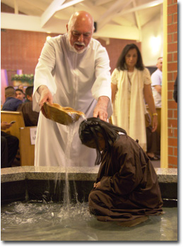
Thank you for the gift of our godchild.
May our godchild come to know you,
the one true God,
and Jesus Christ, whom you have sent.
May your Holy Spirit help them to grow
in faith, hope, and love,
so they may know peace, truth, and goodness.
May their ears hear your voice.
May their eyes see your presence in all things.
May their lips proclaim your word.
May their hearts be your dwelling place.
May their hands do works of charity.
May their feet walk in the way of Jesus Christ,
your Son and our Lord.
Amen.

- Have Faith Conversations Throughout Your Godchild’s Life

Your godchild is never too small to be watching and learning from you about the faith! Here are some simple ways to begin to walk alongside parents in the transmission of the Catholic faith:
- If possible, sit with your godchild at Mass on Sunday and allow him or her to witness you at worship. As they grow, let them ask you questions about what is happening in the liturgy, and begin to explain the basic parts of the Mass.

- Read to your godchild. Tell the stories of our faith using a toddler Bible or children’s picture Bible.

- Support the parents of the godchild as they teach the first prayers of our faith: Our Father, Hail Mary, Glory Be, and Grace before meals are great places to start. You’ll be surprised how quickly their memory works, and you may have some adorable moments as they struggle to get some of the words just right!

- Tell your godchild that God loves them every chance you get.

Develop a relationship where you naturally discuss God from the earliest days, so that when your godchild grows and has questions about the faith, you are a resource they know is available.

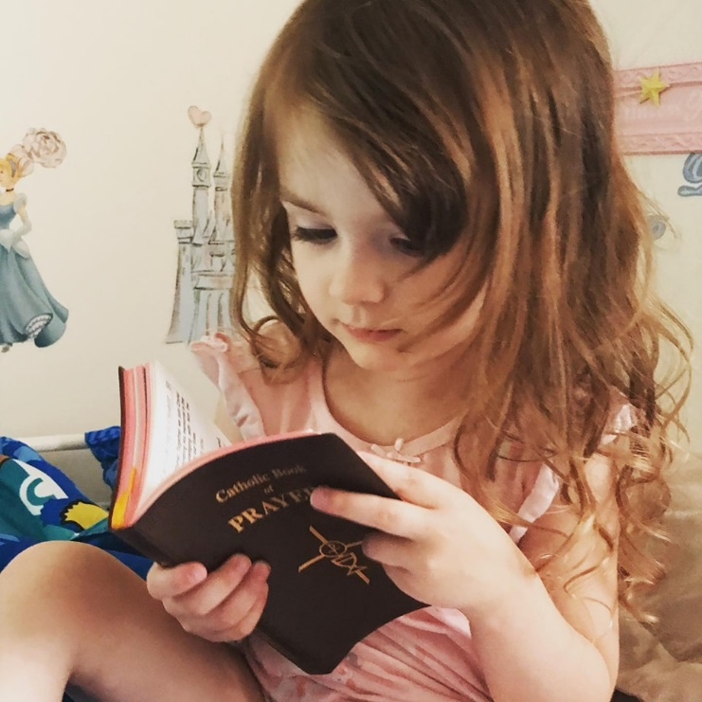

- Celebrate Milestones with Your Godchild
God is in every aspect of our lives, so celebrate every aspect of your godchild’s life! These activities may be helpful places to begin:
- Call or write a letter to your child on his or her birthday. More than a gift, a letter of love and encouragement will have lasting meaning.

- Be active participants in your godchild’s world. Try to attend your godchild’s school activities, sporting events, and concerts. Celebrate all of the talents that God has given your godchild.

- Celebrate your godchild’s anniversary of his or her baptism. Send a card or create a special tradition to celebrate the day your godchild became a Catholic.

- Support your godchild in his or her future sacraments. Go to reconciliation when it is time for your godchild to make his or her First Penance. Accompany your godchild’s family to adoration before his or her First Holy Communion. Continue your faith mentoring role by serving as your godchild’s Confirmation Sponsor.

- Say a prayer of blessing for your godchild in times of transitions: new school years, family moves, graduations, or any other accomplishments.

- Create traditions with your godchild’s family around holidays within the liturgical year. For example, during Lent, you may discuss your Lenten goals and sacrifices, complete an act of service together, attend a community fish fry, or pray the Stations of the Cross. The possibilities are endless! Check with your parish and community for these seasonal opportunities.

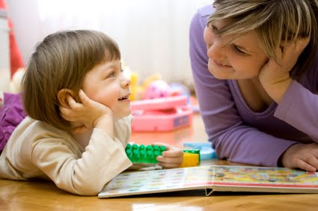

- Seek the Community for Advice
The great beauty of the Catholic Faith is that you are never alone! Seek out the wisdom of your own faith mentors, clergy, fellow godparents, or the multitude of resources found online. Here are five sites to begin your research:

- Tips for Raising Faith-Filled Children
https://diolc.org/files/marriage/conference/Tips-for-Raising-Faith-Filled-Children.pdf
- How to Be A Great Godparent
http://www.catholicdigest.com/family/201404-09how-to-be-a-great-godparent/
- 7 Tips on How to Be A Godparent
http://catholic.net/op/articles/4002/more-than-just-a-title-7-tips-on-how-to-be-a-godparent.html
- Godparents Promise Prayer
https://www.rontranmer.com/a-godparents-promise/
- Catholic Household Blessings and Prayers, USCCB Publishing
https://www.usccb.org/resources/catholic-household-blessings-and-prayers

“Baptism is the door to life and to the kingdom of God. [Christ] entrusted this sacrament and the gospel to his Church when he told his apostles: “Go, make disciples of all nations, and baptize them in the name of the Father, and of the Son, and of the Holy Spirit.” That is why the Church believes it is her most basic and necessary duty to inspire all, catechumens, parents of children still to be baptized, and godparents, to that true and living faith by which they adhere to Christ…”
-Rite of Baptism for Children, pg. 11

Reflections from Veteran Godparents: Hopeful Stories
What does it look like to have a life-long relationship with your godchild? We asked Catholics who have lived out their promises as a godparent to share their experience:
“I was first a sponsor to Marisa at her confirmation and then became godmother to her two little boys. Being the sponsor/godmother to each is an honor and I see it as a lifetime job (though I don’t think each realized I would take it so seriously when I was asked). Each time I say yes, I feel more connected to my faith, too. I love taking each to church with me, praying for them, and checking in on their development in life.”
~Antoinette, Denver

“My godson Matthew’s father is never around. A few months ago, he lost his grandfather. I am also his sister’s godfather, and I treat them like my own kids. Now I am making an effort to be even more involved in his life. He has a family and community in the Church. I am hiring him to be one of my roadies in my event company this summer. I spent time after Church this Sunday with him, his mother, and his grandmother celebrating the end of his first year in college, breaking bread, and laughing about life! Being a godparent is being present. God takes care of the rest.”
~ Joe, Chicago

\

Prayer of St. John the Baptist
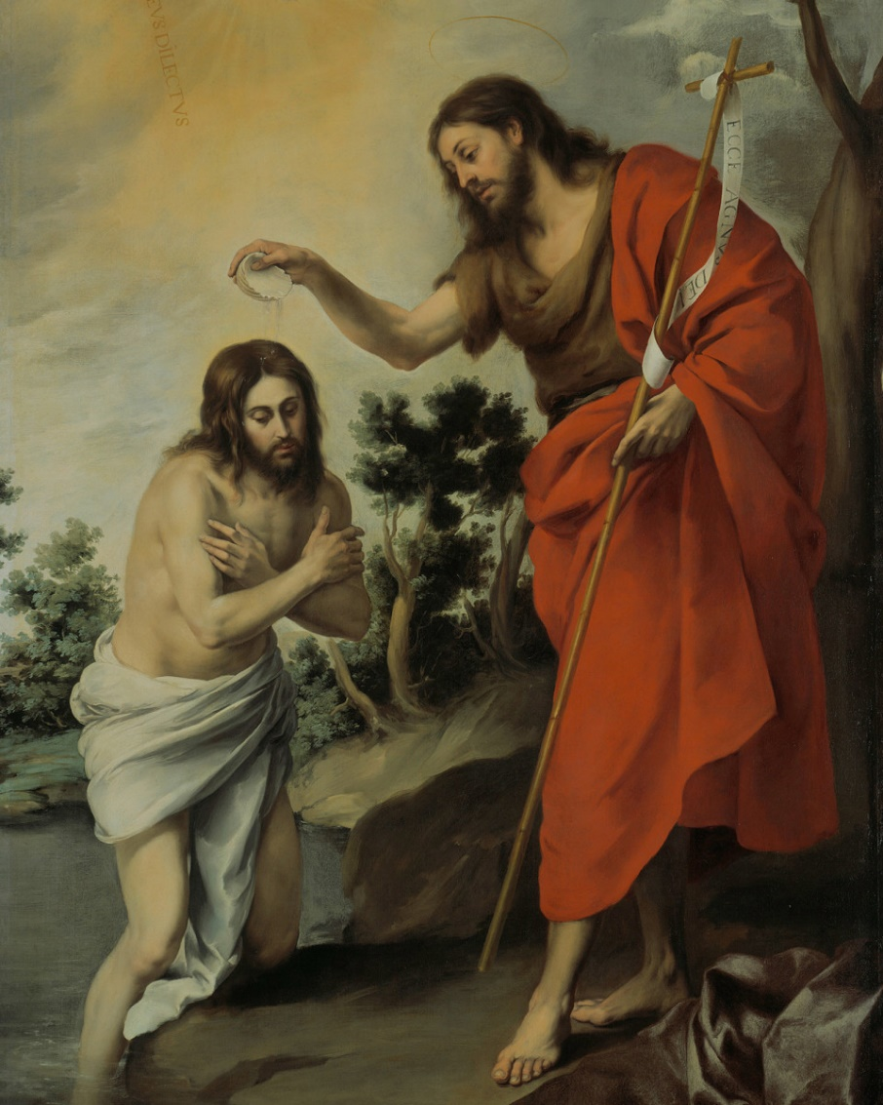

O most zealous Apostle, John the Baptist, who, without working any miracle on others, but solely by the example of your life of penance and the power of your word, drew the multitudes, in order to dispose them to receive the Messiah worthily and to listen to His heavenly doctrine; grant that it may be given unto us, by means of your example of a holy life and the exercise of every good work, to bring many souls to God, but above all those souls that are enveloped in the darkness of error and ignorance and are led astray by vice.
O God, who has made this day, grant to your people the grace of spiritual joy, and direct the minds of all the faithful into the way of everlasting salvation. May we seize each day’s opportunity to grow in holiness and reflect that holiness to those in our care.
Amen.
Photo Credits:
Page 1: Photo by Our Lady of the Lakes, Baptism, Miami Lakes, Florida.
Page 3: Photo by Our Lady of Africa, Mbuya, Kampala, Uganda
Page 4: Photo by Saint Joseph Catholic Church, Baptism, Sound Bend, Indiana.
Page 6: (Upper right) Photo held in public domain by Unsplash.
(Lower right) Photo by Saint Bernard Parish, Los Angeles, California
Page 7: Photo by Megan Cottam, Public Domain.
Page 8: Photo held in public domain by Unsplash.
Page 10: (Upper left) Photo by Antoinette Choate, used with permission
(Lower right) Photo by Christine Delfin, used with permission
Page 11: Murillo, “The Baptism of Christ.” 1655. Public Domain, Creative Commons license.

Prayer Credits:
Page 6: Adapted from “Prayer for Parents.” Diocese of London. Creative Commons
license.
Page 11: Adapted from “Prayer to St. John the Baptist.” Traditional Catholic Prayers
Public Domain

All testimonies are original to this document and used with permission.

