Celebrating the Journey of Faith Together:
A Guide to Your Role as a Catholic Sponsor

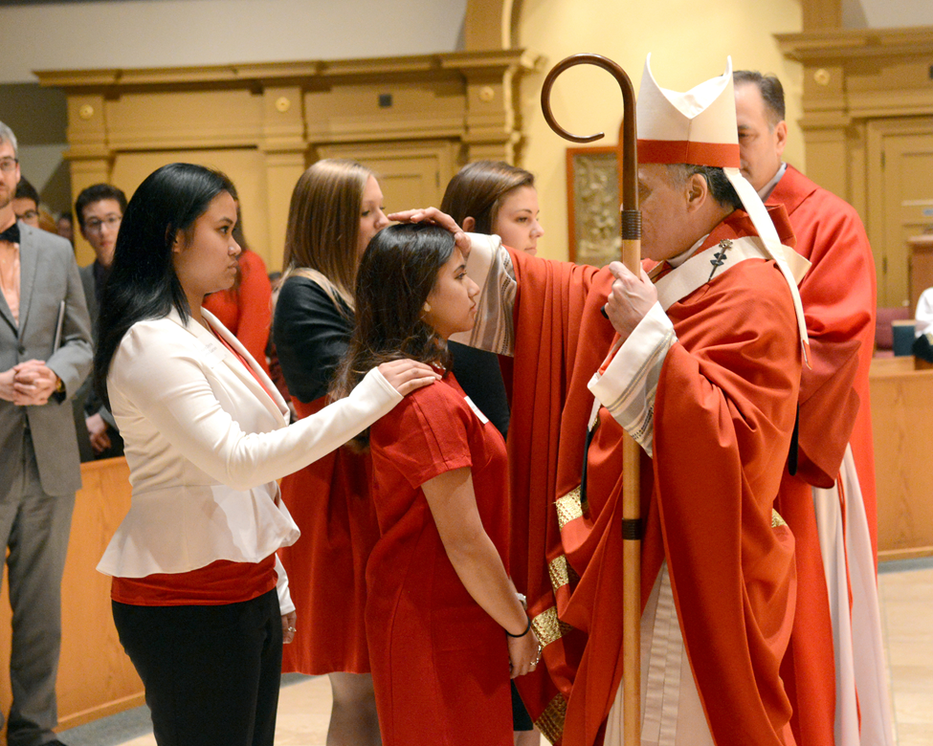

[SAMPLE FOR PARISH USE]

June 24, 2019

Dear Sponsors,

Congratulations! You have been chosen to serve as a sponsor, a duty crucial to the vitality of the Church. Your very life has evangelized others, growing their faith in the truth of Jesus Christ. Thank you for your commitment and witness to the Church.

On this Solemnity of the Nativity of John the Baptist, we recall that John was called to go before the Lord and prepare a way for Christ. So, too, are you making room for others to see Christ more clearly.

This is the beginning of an exciting, life-long mentorship, walking alongside another person on their journey of faith. Included in this resource, I hope you find encouragement and support as you undertake this sacred responsibility. Be assured of my prayers for you as you minister to our growing Church in this way.

Sincerely in Christ,

(Pastor)

Prayer of the Sponsor
Breathe in me, O Holy Spirit,
that my thoughts may all be holy.
Act in me, O Holy Spirit,
that my work too may be holy.
Draw my heart, O Holy Spirit,
that I love but what is holy.
Strengthen me, O Holy Spirit,
to defend all that is holy.
Guide me then, O Holy Spirit,
that I always may be holy.
Amen.
-St. Augustine
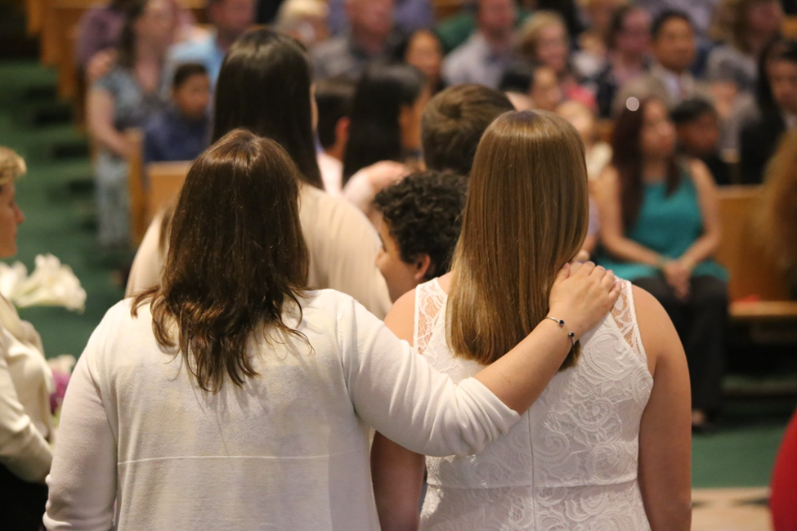

Confirmation Through the Eyes of a Sponsor

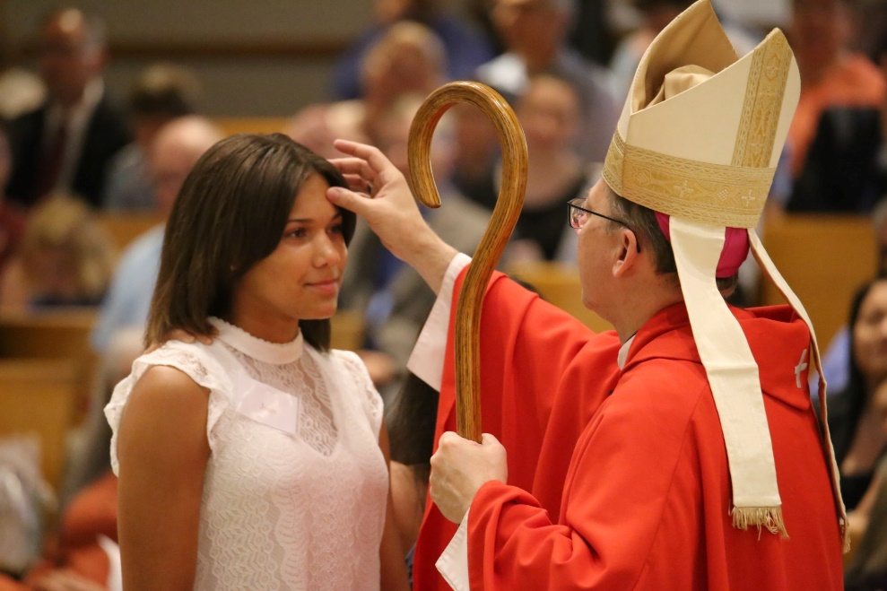
Being Mary’s Confirmation sponsor was one of the most beautiful and enriching experiences of my Catholic faith. Going into it, all I knew was that I wanted her to feel like she belonged in the Church and that I was there for her. And I wanted to journey with her – she had so many questions! Her enthusiasm and determination to learn more about her faith pushed me to recommit to my own faith, the faith that we share with our Catholic community.
On the day of her Confirmation, the church was crowded, kids kept calling Mary over to take pictures with them, and she and I made sure to remember where we had to walk and what we had to say. After the homily, the usher started bringing candidates and sponsors up in pairs to the bishop. That’s when I realized that this was the moment. This was the moment where Mary would receive the Holy Spirit, where she would receive the gifts of knowledge and wisdom and all the rest. She would be able to lead other people to Christ in a brand new way. As we approached the bishop, all I could do was smile. What a gift it was to be able to witness to the Church that Mary was going to take on this mission!
Now, a year after her Confirmation, I still love my conversations with Mary. She continues to ask hard questions, and I hope she keeps asking them throughout the rest of our lives. I am so incredibly thankful for being given the opportunity to be her sponsor. God worked through her to help my own heart be more open, and I trust that God is using me as an instrument in her life so that she continues to journey closer to Him, too.

“A Christian is never bored or sad. Rather, the one who loves Christ is full of joy and radiates joy.”
-Pope Francis

There are few things in life that are pure joy. These are moments where Christ leaps from our hearts, radiating love to one another in response to the grace felt from His love to us. The role of the godparent or sponsor is a sacred witness to this joy; moments where we have the opportunity to walk alongside those experiencing Christ—our friends, family, and community members--as they receive an abundance of grace and joy in the sacramental life of the Church.
Christ gave us the gift of community so that we may always be able to see His light reflected in one another. As a role model in the Catholic Community, you have been chosen to reflect God’s light to others. In every life stage, the Lord knows we need one another. Entering the Catholic Church is not a private moment, but a public celebration in our faith lives that is sustained through life-long support and mentoring.
The introduction to the Rite of Confirmation presents the ongoing role of the sponsor to us:

“Sponsors bring the candidate to receive the sacrament, present them to the minister for anointing, and will later help them to fulfill their baptismal promises faithfully under the influence of the Holy Spirit whom they have received.”
- The Rites of the Catholic Church, Volume 1, pg. 480
-Pope Francis

May you experience countless blessings along this holy adventure, may you feel the encouragement from the Church in your developing relationship, and may God continue to show Himself through your journey together.

Becoming a Great Sponsor: Practical Tips
The Sponsor’s ministry is one of presence, witness, and support. Below are some ideas to get you started in building a faith-filled relationship with your candidate.

- Pray for your Candidate
Pray for your candidate during his or her formation and throughout his or her life, that they may grow in faith! Here’s a sample prayer to get you started:

Gracious and Holy Father,
Please give my candidate:
intellect to understand you,
reason to discern you,
diligence to seek you,
wisdom to find you,
a spirit to know you,
a heart to meditate upon you,
ears to hear you,
eyes to see you,
a tongue to proclaim you,
a way of life pleasing to you,
patience to wait for you
and perseverance to look for you.
Grant them a perfect end,
your holy presence,
a blessed resurrection
and life everlasting.
Amen.

- Have Faith Conversations Throughout Your Candidate’s Life

Your candidate is looking for good role models, for people to inspire them to authentically and joyously live their faith! Here are some simple ways to walk alongside your candidate in the transmission of the Catholic faith:
- Text a daily or weekly Scripture verse for your candidate to reflect on.
- At the beginning of the preparation process, give your candidate a set of rosary beads and invite him or her to pray a Rosary with you every week leading up to Confirmation.
- Ask your candidate to make a list of questions they have about the Catholic faith, and then spend some time with the Catechism of the Catholic Church or the YouCat looking up the answers together and discussing.
- Post spiritually encouraging notes in places that your candidate will see on social media.
- Ask your candidate about their favorite saint, and share with them some saints who have inspired you.
- Find a community service activity in your area, and invite your candidate to serve alongside of you. Afterwards, you can talk about how the Corporal and Spiritual Works of Mercy are practical ways we can live out our faith.
- Invite your candidate to go to Confession with you (most parishes have Confession available at least once a week). This sacrament of healing will help your candidate be open to all of the grace God wishes to bestow on them.
- Plan to attend Mass together, and eat a meal together afterwards. If you live far away from your candidate, consider occasionally reading the Sunday Mass readings together over something like Skype before you both attend Mass.
- Find a place where Eucharistic Adoration is happening near you, and invite your candidate to come spend an hour in prayer together.
- Tell your candidate that God loves them, has a plan for them, and will never abandon them every chance you get.

Develop a relationship where you naturally discuss God so that as your candidate matures and has questions about the faith, you are a resource they know is available.

- Celebrate Milestones with Your Candidate
God is in every aspect of our lives, so celebrate every aspect of your candidate’s life! These activities may be helpful places to begin:
- Call or write a letter to your candidate on his or her birthday. More than a gift, a letter of love and encouragement will have lasting meaning.

- Be active participants in your candidate’s world. Try to attend your candidate’s school activities, sporting events and concerts. Celebrate all of the talents that God has given your candidate.

- Celebrate your candidate’s anniversary of his or her Confirmation. Send a card or create a special tradition to celebrate the day your candidate became a fully-initiated Catholic.

- Say a prayer of blessing for your candidate in times of transitions: new school years, family moves, graduations, or any other accomplishments.

- Create traditions around holidays within the liturgical year. For example, during Lent, you may discuss your Lenten goals and sacrifices, complete an act of service together, attend a community fish fry, or pray the Stations of the Cross. The possibilities are endless! Check with your parish and community for these seasonal opportunities.
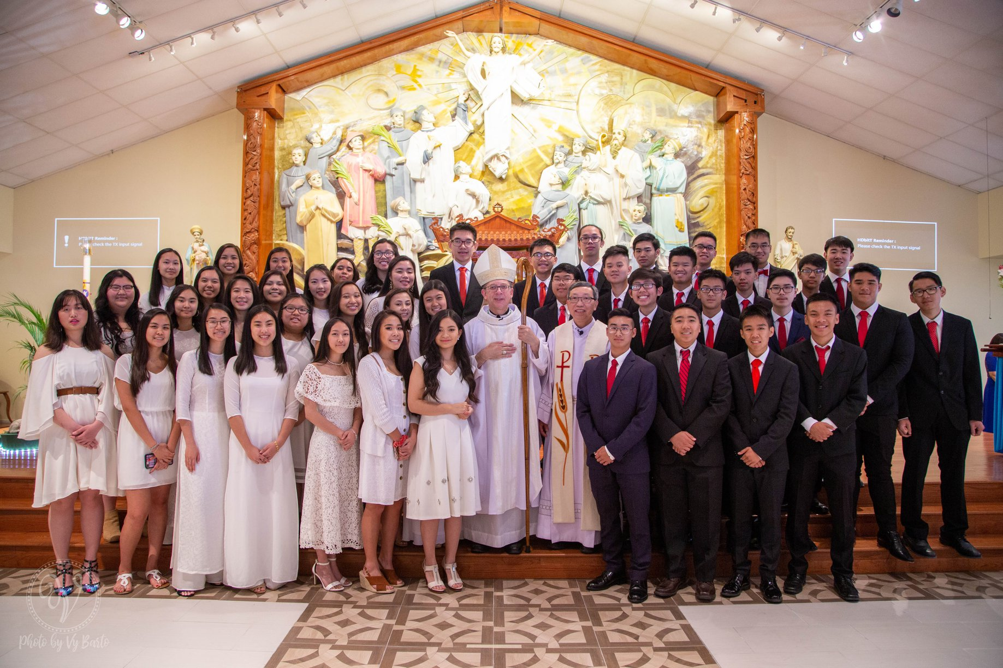
- Seek the Community for Advice
The great beauty of the Catholic Faith is that you are never alone! Seek out the wisdom of your own faith mentors, clergy, fellow sponsors, or the multitude of resources found online. Here are five sites to begin your research:

- Tips For Raising Faith-Filled Children
https://diolc.org/files/marriage/conference/Tips-for-Raising-Faith-Filled-Children.pdf

- 5 Tips for Being the Best Confirmation Sponsor
https://nationalviews.com/five-tips-best-confirmation-sponsor

- Sponsoring a Teen for Confirmation
http://thecatholicspirit.com/spotlight/sponsoring-a-teen-for-confirmation/

- 8 Things You Need to Know about Confirmation
https://lifeteen.com/blog/8-things-you-need-to-know-about-confirmation/

- Biggest and Best List of Confirmation Saints
https://lifeteen.com/blog/biggest-best-list-confirmation-saints-guys-girls/

“[Confirmation] gives us a special strength of the Holy Spirit to spread and defend the faith by word and action as true witnesses of Christ, to confess the name of Christ boldly, and never to be ashamed of the Cross.”
-Catechism of the Catholic Church #1303

Reflections from Veteran Godparents & Sponsors: Hopeful Stories
What does it look like to have a life-long relationship with your godchild, confirmand, or neophyte? We asked Catholics who have lived out their promises as godparent and sponsor to share their experience:
“I was first a sponsor to Marisa at her confirmation and then became godmother to her two little boys. Being the sponsor/godmother to each is an honor and I see it as a lifetime job (though I don’t think each realized I would take it so seriously when I was asked!). Each time I say yes, I feel more connected to my faith, too. I love taking each to church with me, praying for them, and checking in on their development in life.”
~Antoinette, Denver

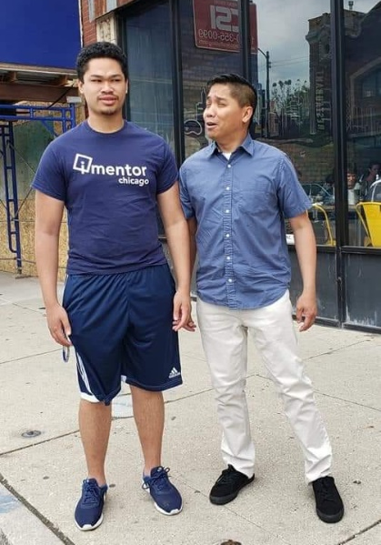
“My godson Matthew’s father is never around. A few months ago, he lost his grandfather. I am also his sister’s godfather, and I treat them like my own kids. Now I am making an effort to be even more involved in his life. He has a family and community in the Church. I am hiring him to be one of my roadies in my event company this summer. I spent time after Church this Sunday with him, his mother, and his grandmother celebrating the end of his first year in college, breaking bread and laughing about life! Being a godparent is being present. God takes care of the rest.”
~ Joe, Chicago
Prayer to the Holy Spirit

Come Holy Spirit, fill the hearts of your faithful
and kindle in them the fire of your love.
Send forth your Spirit and they shall be created.
And You shall renew the face of the earth.
O, God, who by the light of the Holy Spirit,
did instruct the hearts of the faithful,
grant that by the same Holy Spirit we may be truly wise
and ever enjoy His consolations,
Through Christ Our Lord,

Amen.

“We can study the whole history of salvation, we can study the whole of Theology, but without the Spirit we cannot understand. It is the Spirit that makes us realize the truth or – in the words of Our Lord – it is the Spirit that makes us know the voice of Jesus.”
-Pope Francis

