Celebrating the Journey of Faith Together:
A Guide to Your Role as an RCIA Sponsor and RCIA Godparent

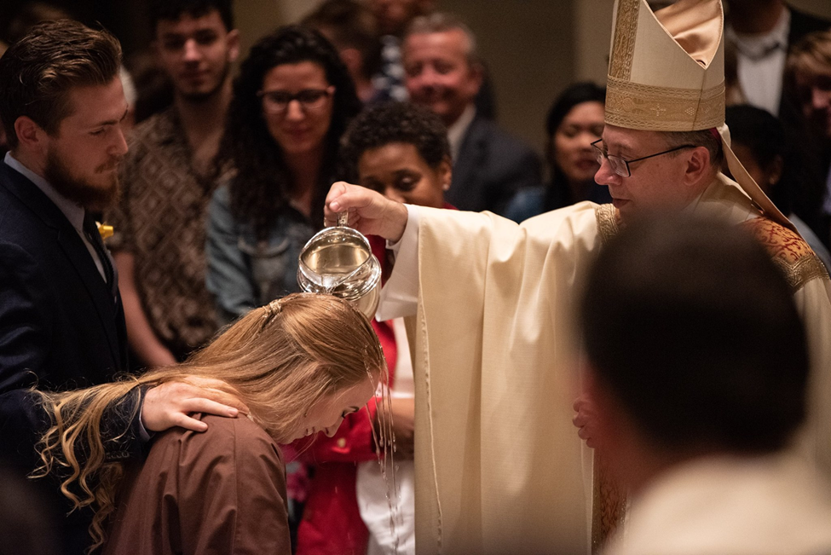

[Sample for Parish Use]

June 24, 2019

Dear Sponsors and Godparents,

Congratulations! You have been chosen to serve as a sponsor or godparent, a duty crucial to the vitality of the Church. Your very life has evangelized others, growing their faith in the truth of Jesus Christ. Thank you for your commitment and witness to the Church.

On this Solemnity of the Nativity of John the Baptist, we recall that John was called to go before the Lord and prepare a way for Christ. You also are making room for others to see Christ more clearly.

This is the beginning of an exciting, life-long mentorship, walking alongside another person on their journey of faith. Included in this resource, I hope you find encouragement and support as you undertake this sacred responsibility. Be assured of my prayers for you as you minister to our growing Church in this way.

Sincerely in Christ,

[Pastor]

Prayer of the Godparent and Sponsor
God of light and love,
thank you for the joy of being a faith mentor,
and the opportunities it gives us to journey with our catechumens and candidates as they grow in faith.
Keep us faithful to the promises we have made to pray for them,
and to encourage them to deepen their relationship with you.
Help us to be a prayerful, supportive, and loving presence in their lives,
And to model to them a life rooted in you:
the way, the truth, and the life.
Amen.
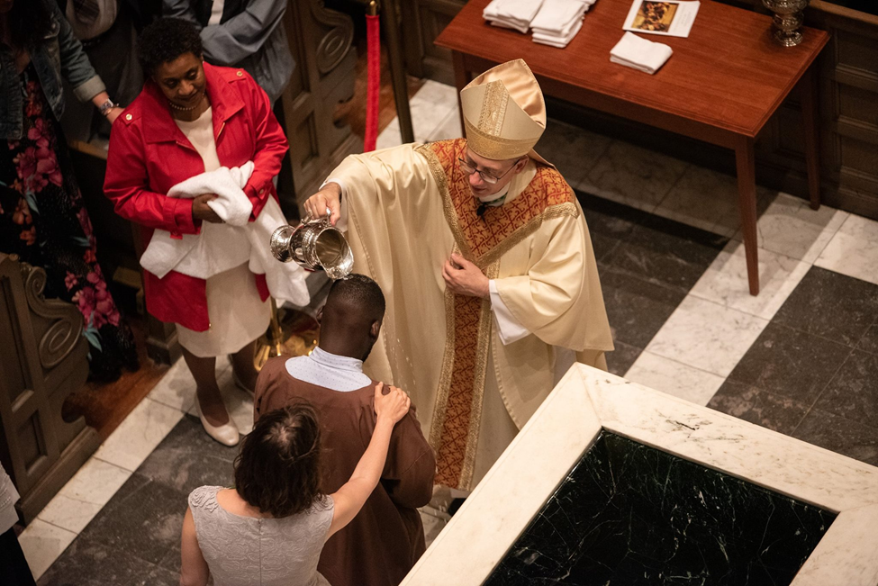

You have been asked to be a sponsor or godparent for someone in RCIA …so what does that mean?
Godparent
A godparent is chosen to accompany someone seeking baptism in the Catholic Church. When this person is older than age seven, they participate in the RCIA and are considered a catechumen. A catechumen usually chooses his or her own godparent. Your role of godparent officially begins at the rite of election where you attest to the readiness of the catechumen for baptism and a life of discipleship. Before this time, the catechumen has been journeying with their sponsor.
Sponsor
A sponsor is chosen to accompany someone who is either…
1. a catechumen (unbaptized) who is seeking to become Catholic. The sponsor will accompany them during their journey, starting at the rite of acceptance, and continuing through the period of the catechumenate. Because this is a lengthy process, the sponsor should be local and a member of the church where the baptism and full initiation intends to take place. The role of sponsor officially stops prior to the rite of election. At that time the catechumen chooses a godparent (see above).
2. already baptized in another Christian faith and is seeking full communion with the Catholic Church through the celebration of confirmation and first holy communion. The sponsor will attest to the readiness of the candidate and stand at the candidate’s side during the rite of confirmation.
3. already baptized Catholic looking to recommit to the faith of their baptism by completing their sacraments of initiation. The sponsor will stand at the candidate’s side during the rite of confirmation.

“As they become familiar with the Christian way of life, and are helped by the example and support of sponsors, godparents, and the entire Christian community, the catechumens learn to turn more readily to God in prayer, to bear witness to the faith, in all things to keep their hopes set on Christ, to follow supernatural inspiration in their deeds, and to practice love of neighbor, even at the cost of self-renunciation.”
-Rite of Christian Initiation of Adults, 75.2

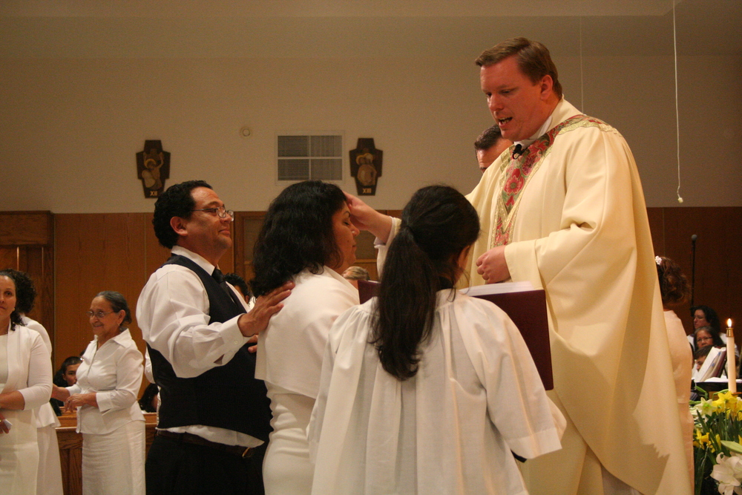
RCIA Sponsors and Godparent Make All the Difference

I wandered in and out of several religions through my young adulthood. From the Buddhists to the Baptists, I faded in and out of enthusiastic faith experiences that never quite stuck. I studied all the doctrines. I read the logical arguments and proofs for the existence of God. I was starving, and the Church was to become my nourishment.
I needed to get out of my head, however. It wasn’t a theological degree I needed. I didn’t need the perfect quote from a catechism. I needed someone who knew me, and who knew Christ, and could bridge the gap between us. I found that in my sponsor. Bob called me out on my fruitless intellectual pursuit. He said, “What you are looking for you cannot find in a textbook.” He invited me to adoration, and together we knelt in silence. He remained with me for the hour. My heart was fed through the Eucharistic presence and I never looked back.
In what started as a defensive relationship debating doctrine, I would never wish for anyone else to have stood beside me on the day of my entry into full communion of the Catholic Church. To this day, we meet for adoration, and then talk about our lives. Sometimes it seems as though the topics are trivial, but Bob reminds me that God is in every aspect of our lives. He still has a way of pointing out the presence of God in my stories, even when I cannot see Him myself. I could not have made this leap of faith without my sponsor to guide me home.

“A Christian is never bored or sad. Rather, the one who loves Christ is full of joy and radiates joy.”
– Pope Francis, June 30, 2013

There are few things in life that are pure joy. These are moments where Christ leaps from our hearts, radiating love to one another in response to the grace felt from His love to us. The role of the godparent or sponsor is a sacred witness to this joy; moments where we have the opportunity to walk alongside those experiencing Christ—our friends, family, and community members--as they receive an abundance of grace and joy in the sacramental life of the Church.
Christ gave us the gift of community so that we may always be able to see His light reflected in one another. As a role model in the Catholic Community, you have been chosen to reflect God’s light to others. In every life stage, the Lord knows we need one another. Entering the Catholic Church is not a private moment, but a public celebration in our faith lives that is sustained through life-long support and mentoring.
The Rite of Christian Initiation for Adults explains this intimate role:

“It is the responsibility of the godparents to show the candidates how to practice the Gospel in personal and social life, to sustain the candidates in moments of hesitancy and anxiety, to bear witness, and to guide the candidates’ progress in the baptismal life.”

-Rite of Christian Initiation of Adults, 11

May you experience countless blessings along this holy adventure, may you feel the encouragement from the Church in your developing relationship, and may God continue to show Himself through your journey together.

Becoming a Great Godparent or Sponsor: Practical Tips
- Be a witness to full, conscious, and active participation in the liturgy. You can do this by accompanying the catechumens and candidates to Mass every Sunday, encouraging them to pray over the readings before coming to Mass, teaching the them the people’s responses in the liturgy, and also the appropriate postures and gestures and the reasons for those postures and gestures.

- Share your own experiences. Lead him or her closer to Christ by telling your catechumen or candidate about your own spiritual journey.

- Spend time talking and listening. Help your catechumen or candidate grow in understanding and acceptance of Christ and the teachings of His Church.

- Pray for your catechumen or candidate regularly. Pray that he or she will not only come to know about the faith but also will encounter Christ while preparing to receive the sacrament(s). As a sponsor, commit to lifting your catechumen or candidate up in prayer every day.

- Encourage him or her to grow in virtue and to set aside any habits that would prevent his or her soul from being fully open and ready to receive all the gifts that God wants to give through the sacraments.

Seek the Community for Advice
The great beauty of the Catholic Faith is that you are never alone! Seek out the wisdom of your own faith mentors, clergy, fellow godparents and sponsors, or the multitude of resources found online. Here are four sites to begin your research:

Role of the Sponsor
https://teamrcia.com/2007/08/sponsors-nine-things-to-know-before-you-say-yes/

Prayer suggestions for RCIA Sponsors
https://teamrcia.com/2012/03/five-essential-elements-of-an-rcia-sponsors-job-description/

How to Be A Great RCIA Sponsor
https://catholicmom.com/2013/01/20/tips-for-rcia-sponsors/

RCIA (with Children): Tips For Raising Faith-Filled Children
https://diolc.org/files/marriage/conference/Tips-for-Raising-Faith-Filled-Children.pdf

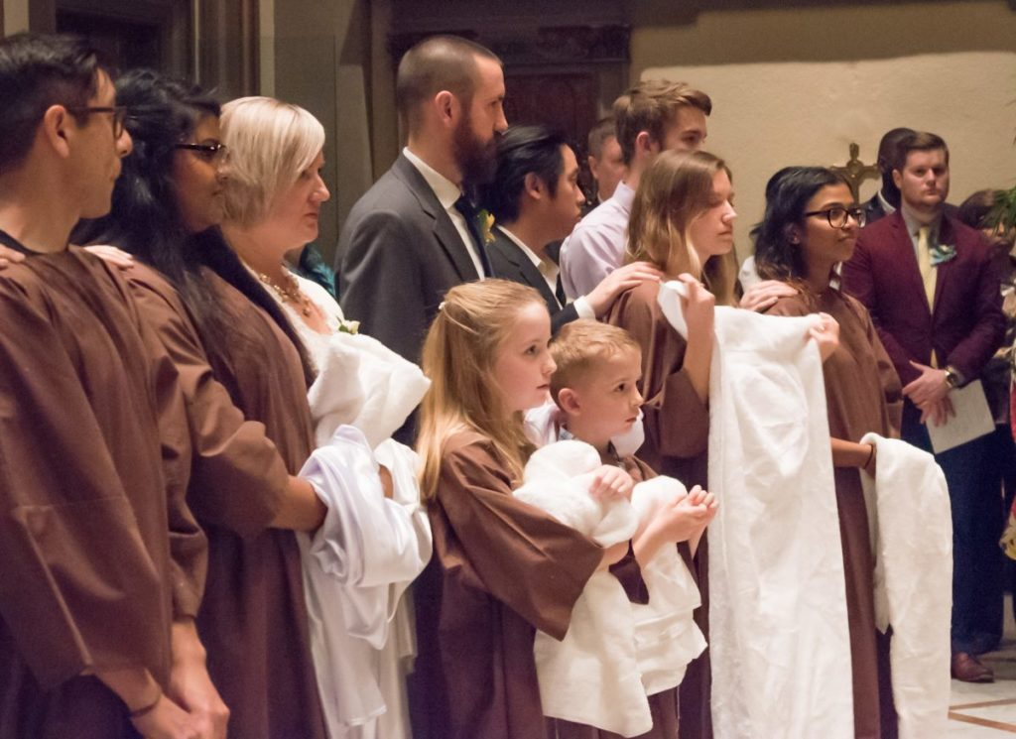

Reflections from Veteran Godparents and Sponsors: Hopeful Stories
What does it look like to have a life-long relationship with your neophyte? We asked Catholics who have lived out their promises as an RCIA godparent or sponsor to share their experience:
“I sponsored Gabriela, a 10-year old girl, as she received the sacraments for the first time at the Easter Vigil. She told me that she felt like a queen on that day, all dressed in white. I remind her on days when she is lonely or sad that she is now that queen forever! We get ice cream together, share laughter, and enjoy one another’s company. Although she is a child, she continues to teach me about my own faith through her questions! I smile every time I see her family come to church, and I make sure they are connected to all the parish activities. Being a sponsor is as simple as loving a child!” ~Flor

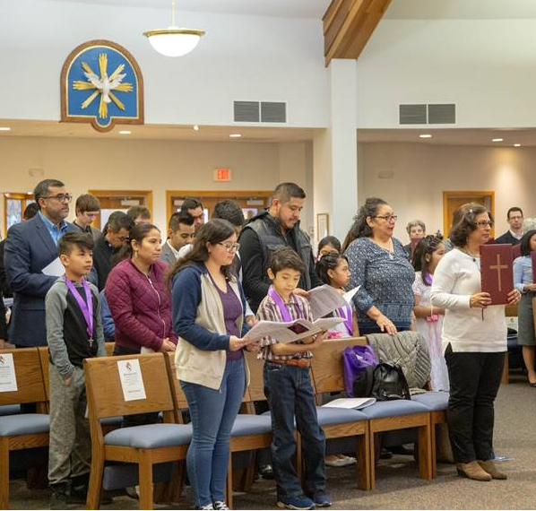

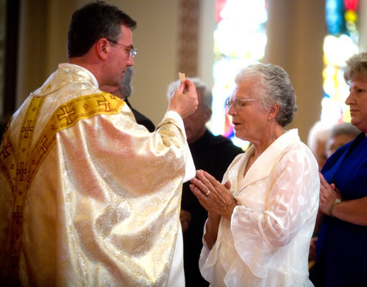
“It was an honor to walk beside Tori as she entered the Catholic Church. Every tenet of the faith that I took for granted, she absorbed with the excitement of a child. We took classes together, and it became evident that this walk was less me teaching her, and more God teaching both of us. At the Easter Vigil, she received the Eucharist for the first time, and wept. I will remember that moment forever, for it renewed my own sense of awe and wonder at the beautiful gift of our faith.” ~ Maria

Prayer of St. John the Baptist
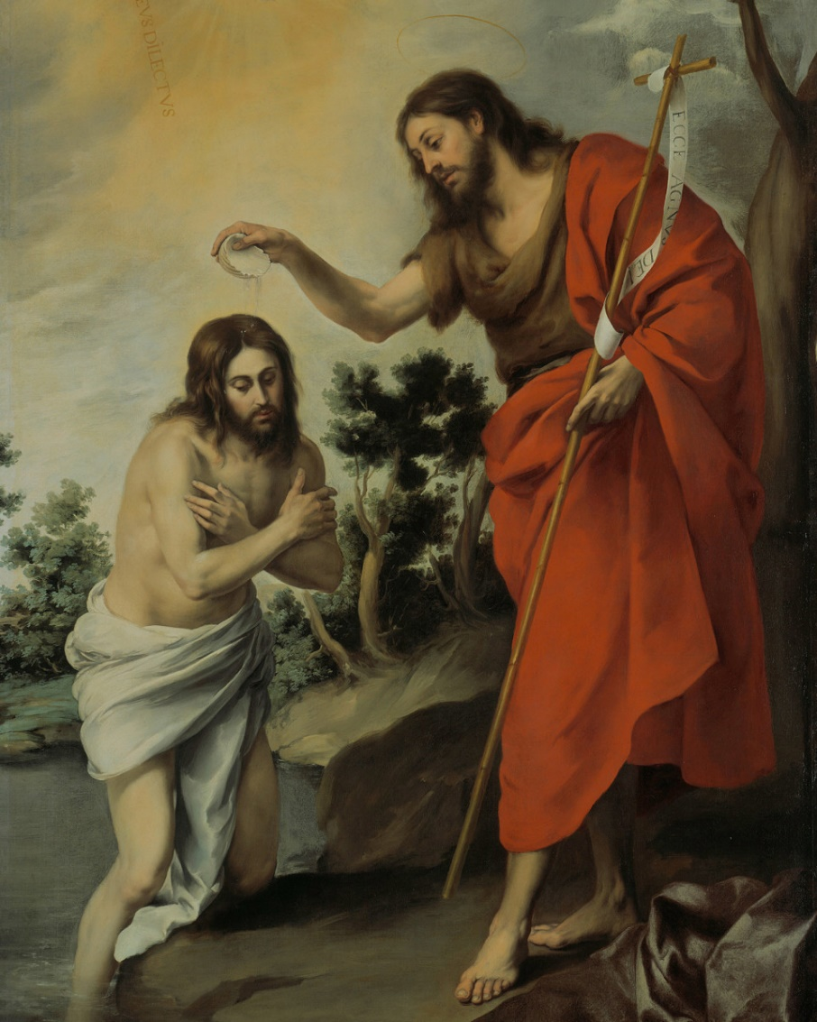

O most zealous Apostle, John the Baptist, who, without working any miracle on others, but solely by the example of your life of penance and the power of your word, drew the multitudes, in order to dispose them to receive the Messiah worthily and to listen to His heavenly doctrine; grant that it may be given unto us, by means of your example of a holy life and the exercise of every good work, to bring many souls to God, but above all those souls that are enveloped in the darkness of error and ignorance and are led astray by vice.
O God, who has made this day, grant to your people the grace of spiritual joy, and direct the minds of all the faithful into the way of everlasting salvation. May we seize each day’s opportunity to grow in holiness and reflect that holiness to those in our care.
Amen.
Photo Credits:
Page 1, 3: Photo by Vy Barto, Easter Vigil with His Excellency Bishop Barry C. Knestout,
Cathedral of the Sacred Heart, April 20, 2019
Page 5: Photo by Resurrection of Our Lord Parish, Archdiocese of Baltimore, Easter Vigil Confirmation with Pastor Emeritus Fr. Mark S. Bialek
Page 7: Photo by Steven Van, UnSplash Public Domain image
Page 8: Cathedral of the Sacred Heart, Rite of Christian Initiation of Adults, Easter Vigil
Page 9: (Upper right) Photo by Vy Barto, Rite of Election, Our Lady of Perpetual Help,
Salem, 2019
(Lower left) Photo by Saint Dennis Parish, Madison, Wisconsin.
Page 10: Murillo, “The Baptism of Christ.” 1655. Public Domain, Creative Commons license.

Prayer Credits:
Page 10: Adapted from “Prayer to St. John the Baptist.” Traditional Catholic Prayers-Public Domain

All testimonies are original to this document and used with permission.

