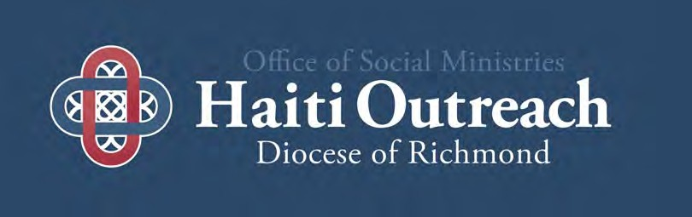

Diocese of Richmond
Global Partnership
Handbook

Questions from Haiti’s
Bishops about Global Partnership
in Haiti

How is Haitian leadership being respected
& promoted from the beginning of any initiative?
Are skills being developed that would allow Haitians to manage similar projects in the future? Is local
decision-making and leadership being
supported?

Haiti Catholic Conference of
Bishops,
partners in mission

Table of Contents

Overview | 3 - 16
Parish-based Partnership | 18 -24
Financial Policies & Procedures | 26 -28
Traveling to Haiti | 30-31
Youth Policies | 33
Haiti Vehicle | 35 -36
Child Safety | 38
Additional Information | 40-41

2 of 44

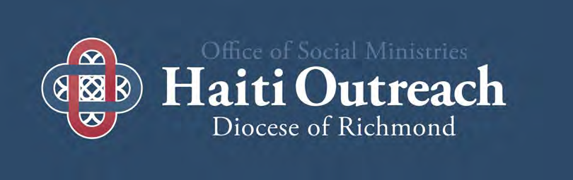

Section I

Office of Social Ministries’
Global Partnership (twinning) Haiti outreach Overview

Message from diocese of Richmond’s Haiti Ministry Commission

Bonjou Zanmis / Partners in Ministry,

Through the efforts of many past and present members of the Diocesan Haiti Outreach Ministry, a vibrant and enduring partnership has emerged and grown. Through this handbook, we continue in our efforts to grow the Ministry through the Haiti Commission’s support of your parish-based relationships in Haiti. The resources available in the handbook are meant to assist you in your parish-to-parish Haiti ministry efforts. Through our participation in Haiti Ministry, we take a walk of faith, a journey built out of mutual respect and caring in the Diocese of Hinche and the Diocese of Richmond. Through mutual conversations and spiritual growth, we hope to increase communication, collaboration, growth, and capacity building. Through these initiatives, the effectiveness of each of the twinning ministries and diocesan bodies will be promoted and valued.

This handbook is meant to be a balance between principles and policies, assisting you with your work with your local Pastor and parish leadership, along with your counterparts in your twin parish/organization in Haiti. We hope to promote and support Haitian leadership, to be strengthened through our humility and openness. We desire to develop covenant based global partnerships – where all expectations are shared and agreed to by the two partners and provide an environment of trust through diocesan policies and consistency throughout all the relationships.

Like you, we believe that our Ministry in Haiti is a journey of faith. We know that the essence of twinning is a mutually respectful relationship. We recognize the important differences between the work of this Ministry and that of Government and Non- Governmental organizations (NGO), Social Services agencies and For- Profit service providers. We strive for solidarity with our Haitian brothers and sisters as we walk in the footsteps of Jesus together, while simultaneously trying to strive to uphold standards and international development models that ensure that all players, Haitians, volunteers, and donors, are honored and respected.

In the words of Pope Francis: “Jesus did not preach his own politics: He accompanied others.” As we walk together on this journey of faith, let our steps be energized and inspired by our brothers and sisters of Haiti.

Lape ak ou / Peace be with you,
Executive Team
Haiti Ministry Commission

- of 44

PARTNERS IN MISSION GUIDELINES FOR SOLIDARITY AND “TWINNING” RELATIONSHIPS
INTRODUCTION
The Church in Haiti has a long tradition of mission solidarity with many parts of the Church around the world. This solidarity is seen in many ways and accounts for the ties of friendship that span the globe and demonstrate the character of true charity described by Pope Benedict XVI in the encyclical letter Caritas in Veritate: charity is a “gift, acceptance and communion.”2
Such generosity was seen in the tremendous outpouring of love and support following the earthquake that struck Haiti on January 12, 2010. Many of these mission relationships are long standing partnerships and have contributed greatly to the infrastructure of the Church in Haiti, as well as the creation and support of Catholic schools, Catholic healthcare institutions, and other Catholic social service agencies throughout the country. The global Catholic community’s longstanding companionship with the Church in Haiti continues to impact millions of children who now have the opportunity to go to school, countless individuals and families who now have access to medical care and safe water, and millions of parishioners who benefit from parish community centers.
In the aftermath of the earthquake that devastated Port-au-Prince and surrounding areas, and placed enormous stress on outlying areas that welcomed those who fled the earthquake zone, the bishops in Haiti are urging all Church partners to renew their commitment to Haiti. To help in the process, the bishops have developed a set of guiding principles contained in this document aimed at promoting ecclesial communion. It is our hope that this moment of trial represents an opportunity for all those who care for Haiti and its people to embrace a vision for global solidarity, partnership and respect that reflects the Gospel call to fraternity, to be in communion with our brothers and sisters around the world, especially those who are most in need of care.

The following guiding principles have been drawn from the experiences of partnership relationships in Haiti and elsewhere as well as a comprehensive study of such relationships that was undertaken by the U.S. Catholic Mission Association.3 They proceed from the reality of the local Church in Haiti and the primary responsibility of each local bishop for pastoral activity in his diocese. They acknowledge that like all relationships, there are ups and downs, moments of strength and weakness, moments of collaboration and misunderstanding. They are offered as guidance for those involved in partnership relationships between the Church in Haiti and the Church in other parts of the world. While developed in the context of the post-earthquake reality in Haiti, they can equally be applied to all efforts at ecclesial partnerships in whatever part of the Church.

- Emphasize relationships as well as resources
A true partnership implies the building and nurturing of a relationship over a period of time that transcends one act of working together (such as a project), or of sending a series of checks. If the partnership is based solely on resources, then the partner with few material resources is excluded from full and mutual participation. When the relationship itself is highly valued, it allows for mutual participation and transformation, and all are invited to participate equally, as we all have the ability to love and pray and be present to one another. Partners learn from one another. It is important that adequate planning, including a timeline of activities and/or visits, be undertaken before a partnership is entered into and that an agreement be drafted and agreed upon by the local bishop. Indeed, as Ecclesia in America teaches: The Bishops, whose duty it is to promote communion among the particular Churches, should encourage the faithful to live this communion more and more, and to assume the “responsibility of developing bonds of communion with the local Churches in other areas of America through education, the exchange of information, fraternal ties between parishes and dioceses, and projects involving cooperation and joint intervention in questions of greater importance, especially those affecting the poor. 4

- Ensure coherence with the pastoral plan for the Local Church
The tragedy of the earthquake can be turned into an opportunity for the Haitian Church and her global partners to provide leadership for the Haitian reconstruction process by offering a model of coordinated, high quality rebuilding. This will require communication and coordination among all Church actors. The Haitian bishops, in cooperation with representatives of the Church from around the world, are establishing an architectural and engineering unit within the Bishops’ Conference called PROCHE. This initiative is designed to provide a contact point for all Church-related reconstruction projects so that an overview of all projects can be maintained an d priorities can be set for larger projects. The organization will operate under the leadership of the bishops of Haiti and will be staffed with certified architects, engineers, and consultant to facilitate Church building projects that meet earthquake- and hurricane-resistant construction standards and appropriate building codes. It will also involve pastoral ministers, social workers, local professionals and community representatives to promote participation by the communities being served. As leaders of the Church in Haiti and other parts of the world, we are requesting that all stakeholders channel their assistance through PROCHE, which will ensure safety and quality by providing a technical and budgetary review of proposed construction projects and by endorsing those projects that are in full compliance with standard and codes, that are fiscally sound and that respect pastoral objectives and methods and promote integral community development. PROCHE will also support information-sharing and coordination among all stakeholders.

- of 44

- Respect Local Church Organization and Planning
The Church’s efforts to rebuild its own structures and programs, and its support for broader reconstruction in Haiti, will be more effective if there is more cooperation and less fragmentation among Church organizations and programs. Parishes and other groups in Haiti and around the world that are engaged in partnering relationships are urged to keep their local bishops informed about these initiatives. No building activity should be undertaken by Church partners in Haiti without the approval of the local bishop and, if applicable, the religious superior.

- Practice Mutuality and Equality
Ongoing and mutual giving and receiving, learning and teaching are essential for global solidarity partnerships. True mutuality allows each of the partners to function from a place of strength. Each must acknowledge the valued role of the other. It is important to intentionally incorporate opportunities for ongoing dialogue, planning, assessing, challenging, and reflecting together. Indeed, solidarity partnering is a form of mission that has been long recognized by the Church. 5 As a form of mission of the local Church in both countries, such partnerships should come under the supervision and organization of the diocesan mission office or other appropriate diocesan body.

- Support Responsible Local Leadership
The true measure of success of any global solidarity partnership is not how many wells were dug or clinics held, but whether the capacity of the local community to lead its own development is strengthened. The goal of any partnership should lead to sustainable development, according to needs of the local Church, and should be designed to reduce the need for outside help. How is Haitian leadership being respected and promoted from the beginning of any initiative? Are skills being developed that would allow Haitians to manage similar projects in the future? Is local decision-making and leadership being supported?

- Promote Transparency and Accountability
Implicit in these principles is the expectation that leaders of both partners will carry out their roles in an honest, transparent and responsible way. Transparency and accountability are essential for strong global partnership relationships. All partnerships should be characterized by open sharing of information so that mutual trust can be developed. Funds provided to Church partners in Haiti should be used in a manner consistent with donor intent and should be reported both to the local mission office or diocesan authority in the sending country as well as the local bishop in Haiti. The results of the project should also be reported to the donors. It is our strong desire that a monthly report on building projects funded by Church entities from around the world be drafted and made available on the appropriate website.

- Work to Promote Greater Justice and Peace
Global solidarity partnerships can provide the experience and the understanding of the challenges facing Haiti to enable those in Haiti to participate in their own country’s decision-making, and to enable those in other parts of the world to participate in donor government policy-making in ways that promote the best interests of the people of Haiti and meet their needs most effectively. Participation in efforts to promote more just policies is a valuable dimension of the partnership experience. All of these activities should be undertaken in consultation and collaboration with Haitian and should promote integral human development for Haitians.

CONCLUSION
Global solidarity partnerships are a vital expression of the Church’s call to be missionary. Indeed, mission is not the sole preserve of religious or priests or the consecrated laity but should be the concern of every Catholic since it goes to the heart of what it means to be Church. As Pope John Paul II taught us in Redemptoris Missio, “Every member of the faithful is called to holiness and mission.”6 The experiences associated with these missionary partnerships give new meaning to the Gospel call to evangelize and to be evangelized in return. They reflect the reality of Christian love that transcends borders and cultures making us truly one. They reveal new ways of understanding the Scriptures and provide new models of being a Catholic believing community, whether school, college, university or medical facility. Through our fellowship, we are followers of Christ as his missionaries and disciples, called to take up his cross daily as we wait in joyful hope for our Savior’s coming when “God will be all in all” (1 Cor. 15:28).

Written by the Haiti Catholic Conference of Bishops

- These guidelines recognize the various ways in which solidarity is expressed between Church units e.g. parishes, dioceses etc. They include sister parish, twinning and partnering. While recognizing the use of these difference terms, these guidelines prefer to refers to such relationships as “partnering for mission.”
- Pope Benedict XVI, Caritas in Veritate, n. 3.
- Partnering Relationships for Mission: An Inquiry and Overview of Diocesan and Parish Twinning. 2004, U.S. Catholic Mission Association. 4 Pope John Paul II, Ecclesia in America, 37.
5 The Congregation for the Evangelization of Peoples. (1999). Cooperatio Missionalis: Instruction on Missionary Cooperation, n. 18. 6 Pope John Paul II, Redemptoris Missio, n. 90

- of 44

Structure of OSM’s
Global Partnership - Haiti Outreach

Office of Social Ministries Haiti Ministry Commission

Diocesan Support Teams

Parish Twinning

- of 44

Section 1. Purpose
The Haitian Ministry Commission has the following responsibilities:
- To work in solidarity with people in developing countries, in particular Haiti.
- To advise the Bishop in the area of global solidarity, in particular Haiti.
- To evaluate and revise, on an annual basis, the pastoral plan on global partnership ministries and be responsible for its implementation.
- To promote awareness and encourage participation throughout the diocese in the global partnership, especially Haiti.
- To foster effective communication and collaboration between the various Haiti ministry areas and committees.
- To coordinate diocesan wide activities which promote and support Global Partnership (Haiti Outreach) such as the annual Haiti Gathering, Regional Gatherings, Haiti Solidarity Week, immersion trips to Haiti and other activities.
- To support and collaborate with the Office of Social Ministries (Haiti Outreach) in the creation of annual financial and programmatic report.
- Establish relationships with USCCB, CRS, the Virginia Catholic Conference, and counterparts in Haiti and other developing countries to work on public policy and justice issues affecting Haiti and other developing countries.
- Support all global solidarity efforts in the Diocese of Richmond
- Approve all new Team projects proposals according to the established “Review” policies

Section 2. Membership
  - Commission make up:
The Bishop will appoint not less than 12 and not more than 24 members to the Commission. Every attempt will be made to have a board representative of the diversity of the Global Partnership Ministries (Haiti Outreach) and the Diocese.
Recommendations for membership will be made using the following guidelines for board make up:
    - Not less than one and not more than two representatives from each Support Team and standing committee.
    - Members of parishes who have twinning relationships. The membership should reflect the diversity of geographic location in Richmond and the geographic location of the twinned entity in Haiti or other developing country.
    - Members representative of the Haitian community or other Diaspora groups.
    - The Director of Global Ministries in consultation with the Executive Team can determine to appoint members exempt from the selection process.

  - Commission member selection process:
Individuals may identify themselves or be recommended by others to apply for membership to the Commission. Each potential member will fill out an application form and submit a reference from their pastor certifying their good standing at their parish, as well as their participation in their parish’s twinning ministry. Following the New Member review process, the Commission will recommend the new members to the Director of Global Ministries. The Director of Global Ministries will finalize the appointment request of new members to the Commission and submit the request to the Bishop for his approval of the new member.

The Office of Social Ministries’ Director of Global Ministries will be an ex officio member of the Commission.

  - Orientation
The Executive Team members, or the Office of Social Ministries’ Global Ministries Rep will orient new members of the Commission.

  - Duration of Term:
Members will serve a term of three years, after which they may be re-appointed for an additional term.
All Commission members serve under the direction of OSM. Failure to attend two consecutive meetings in any year may be considered grounds for a membership review.

  - Responsibilities of members:
    - Serve at least one full term
    - Provide regular reports and updates to the committee.
    - Attend (quarterly) meetings
    - Actively participate on committees, if possible
    - Participate in Commission development activities and retreats
    - Attend special events and community meetings related to Global Partnership Ministries, in particular Haiti Outreach.
    - Be informed on current events related to Haiti and/or other developing countries
    - Develop and maintain a yearly calendar of meetings and events

- of 44

Section 3. Officers
The officers of the Commission shall be the chairperson, the vice-chairperson, the secretary, and on OSM rep. The officers will be elected by the commission.

The Office of Social Ministries’ Rep will serve as the treasurer and will prepare annual financial reports pertinent to the Diocesan Global Partnership Ministries/ Haiti Outreach.

- General Expectations
  - Will serve at least one three-year term
  - Will meet (quarterly) as part of the Executive Team.

- Responsibilities

The Chair will carry out the following responsibilities:
  - Preside over all Commission meetings
  - Meet with the Executive Committee to set the agenda for Commission meetings
  - Assist OSM to assure that the Commission accomplishes its mission as outlined in the Constitution and Pastoral Plan and as set forth in its goals and objectives
  - Maintain a list of names of potential Commission members which reflects the diversity of our community; maintain the Commission at full membership
  - Be responsible for Commission membership development

The Vice Chair will carry out the following responsibilities:
- Preside in absence of chair
- With the Executive Team, appoint a Chair for the Annual Haiti Gathering Planning Workgroup and emcee for the Annual Haiti Gathering.
- With the Executive Team, assist all committees in meeting regularly, establishing their goals and objectives, and in designing their annual budget; monitor committees' progress in these areas through an annual review with the Director of Office of Social Ministries

The Secretary will carry out the following responsibilities:
- Take minutes at all Commission meetings
- Ensure the timely submission and distribution of board and committee minutes and reports
- Send out the agenda and minutes to Commission members before meetings
- Send copies of minutes to the Office of Social Ministries’ Rep and the Executive Team
- Ensure accurate member list for all Partnership Teams
- Review and update Diocesan Approved Organization Master List
- Send out all reminders and important messages from the Executive Team
- Contact the OSM staff members to schedule upcoming meeting(s) including request a meeting location space, date, amount of attendees, IT resources needed – if at Pastoral Center OR will contact Parish directly

Office of Social Ministries’ Global Ministries Staff will carry out the following responsibilities:
- Submit an annual financial report pertinent to the Haiti Outreach Ministries
- Represent the Commission to the Bishop:
  - Advise the Bishop on all appropriate matters
  - Submit to the Bishop the Commission's end of the year project financial report, annual budget, and upcoming year's goals and objectives.
- Provide the Commission with a report of financial activities of the Commission’s funds, Haiti Outreach Boards and an annual report of the Diocesan Partnership (twinning) program.
- Work with the Commission to review and revise all annual goals for Global Solidarity.
- Ensure policies are complied with in all Global Ministries within the DOR.

- of 44

Support Teams
- Executive Team:
Is made up of the Chairperson, vice chairperson, secretary and a diocesan staff ex officio member.

The Executive Team has the following responsibilities:
- Meet at least 4 times a year
- Prepare meeting agendas for the commission
- Prepare a draft of the goals and objectives for the year
- Support the work of the Support Teams
- Review all new project proposals according the review policies
- Assist the Office of Social Ministries to review Diocesan Global Partnership policies

- Specialized Support Teams:
The Commission will have standing teams, with the following responsibilities:

Haiti Partnership Support Team:
- Be a resource and support to parishes who are twinned or considering twinning
- Complete Peer Reviews for all new parish-based projects in partnership with the Hinche Commission
- Develop yearly goals and objectives and submit them to the commission for approval
- Work with the Hinche Commission to identify and implement sustainable economic and ecological projects in Hinche
- Infuse sustainable development concepts into the already existing programs and projects
- Work with and be a resource to twinning parishes through education and formation opportunities
Haiti Education Support Team:
Haitian Education Fund:
•Support the Diocesan Office of Education (BDE) in Hinche
•Manage funds raised by the Commission to support the annual and special projects of the BDE
•Develop yearly goals and objectives and submit them to the commission Shalom Fund:
- Assist in fundraising for the Shalom Fund
- 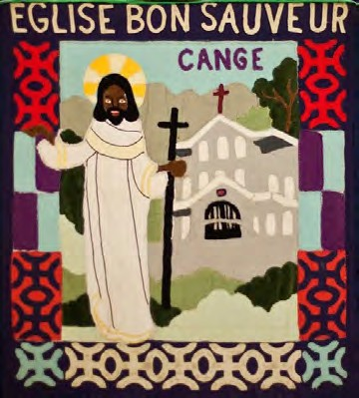Administer the scholarship with the help of the BDE
- Report to the commission on the recipients
Haiti Healthcare Support Team
- To assist parishes with various types of resources in developing healthcare initiatives
- To work closely with Caritas Hinche to support healthcare in the Diocese of Hinche
- To provide informational memos on relevant topics
- To find other possible partnerships for parishes in both dioceses.

Financial Review Team
•To review all partnership financial reports submitted to assure compliance with Diocesan policies
•Follow-up with parishes or schools that have not submitted all needed information
•Request audits through the Diocesan Financial Office on selected parishes that have been determined to need extensive follow up

Additional standing committees may be established by the executive team.

- Ad Hoc Teams/Committees:
May be created by the Executive Team for work on specific projects.

- of 44

Section 7. Team Chairs
Each chairperson will be responsible for the following:
- Ensure that the team meets regularly, setting the agenda, appointing someone to act in their stead, if absent, and making sure minutes are taken
- Keep committee at full membership; recruiting members for the team
- Guide the committee in establishing its yearly goals and objectives; monitoring committee's progress in these areas
- Submitting minutes, annual goals and objective to the Commission
- Meet with the Director of Office of Social Ministries or OSM rep every quarter
6. Contact the OSM staff members to schedule upcoming meeting(s) including request a meeting location space, date, number of attendees, IT resources needed – if at Pastoral Center OR will contact Parish directly

Section 8. Commission Meetings
Meetings shall ordinarily be held four times. The Office of Social Ministries or Commission chairperson may call special meetings to consider urgent matters.
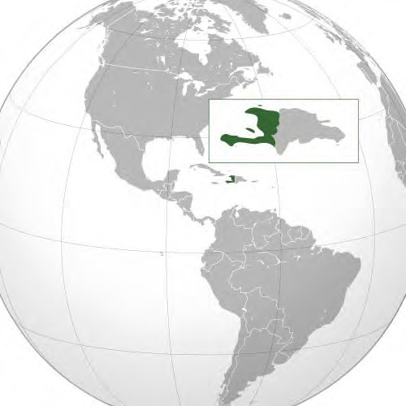As much advance notice as is practical shall be given Commission members concerning the nature of matters to be considered at the meetings.

Bondye di ou. fe pa ou, M a fe pa M.
God says do your part and I'll do mine

- Haitian Proverb

- of 44

Haiti Ministry Commission Policies and Guidelines for Diocesan Support Teams
- Reporting

Minutes:
- All committee minutes are asked to be sent as soon as possible to OSM and the Executive Team of the Haiti Commission (Secretary).
- Included in the minutes, should be a brief overview of the state of the committee by the chair.

- Haiti Ministry Commission Representatives

Appointment:
- Haiti Ministry Chairs are responsible for appointing two representatives to the Haiti Ministry Commission. If possible, these representatives should stay in this position for at least one year.
- OSM suggests making the Committee representative position a two-year commitment. Nevertheless, the final decision rests with the respective chair.

- Projects (New and Ongoing)
Fundraising:
- All fundraising efforts are determined by the respective committee and need to be approved by OSM if parishes will be solicited for funds.
- OSM request that any new efforts be highlighted in the Minutes.
- Please note: There is NO approval process needed for such initiatives.

Ongoing Projects:
No approval is required.

New Projects:
- All Haiti Ministry diocesan teams, boards, foundations, and funds are required to get diocesan approval for any new initiative /project through the Haiti Ministry Commission.
- Please contact OSM if your committee has a question on what would be considered a “new project”.

- Approval for New Projects

The approval process is a 5 step process (pg. 3). Please note that this could take 3-6 months (unless the situation is considered urgent). Therefore, please plan accordingly.
- Hinche Commission: Throughout the approval process, the Hinche Commission will be fully engaged. The Diocese of Hinche will have a fundamental voice in the approval process.
- All new projects will have to go through the approval process.

- Haiti Website
Updates:
  - All teams are asked to keep their website sections current. Every month, you will be able to submit a form for changes and updates. On this form you will be asked to identify the website section and information that needs to be changed. Please be as detailed as possible. This will help to not cause delays.

- of 44

5 Step Approval Process for new support team projects

(this does not apply to parish-based projects)

Step 1: HMC Executive Team Review
Schedule and meet with the Executive Team of the Commission (HMC ASK THAT THE CHAIR IS THE PERSON TO REQUEST A MEETING). At least two weeks before the meeting, a written proposal is asked to be submitted to the OSM and the HMC Executive Team (ET).

Written Proposal
To assist the committee’s written proposal, a Project Proposal Form will be available. On this form, the committee will find guidance for creating a written proposal through a list of what the HMC will be looking for in a written proposal.

Step 2: Executive Team’s Response
Following the meeting, the ET will send an official response to the team’s chair. The official ET response could take up to 1 month. In the ET’s response, the team will receive additional questions about their proposal, recommended changes, and any other information that the ET deems to be important for the success of the committee’s proposal.

Step 3: Schedule with the Haiti Ministry Commission
The team (chair) will request for the project’s final review to be added to the Haiti Ministry Commission quarterly meeting’s agenda - dates (Commission Meetings) will be posted on the website.

Step 4: Final Written Proposal
Following the HMC meeting’s confirmation, it is extremely important that the team submits to the HMC the final written project proposal. This should be done at least two weeks before the HMC final review meeting. In addition, the Haiti Commission Members will be encouraged to ask questions directly to the chair of the team throughout the period before the review meeting.

Step 5: Review Presentation
The team will be asked to present to the commission. Time for the proposal’s presentation will be 15-20 minutes and then 15-20 minutes session for questions and answers.

Decision
Only the two appointed representatives from the team that submitted the proposal will be allowed to be part of the deliberation. The HMC chairs will call a vote for the proposal's approval or disapproval or approval with conditions. Moreover, the Hinche Commission will submit their assessment to the HMC prior to the final vote.

The OSM rep will call a meeting with the team’s leadership to discuss the results. There will be an official response to the team within 1 - 2 months from the Haiti Ministry Commission Executive Team.

Please note that if a proposal is not approved the team can resubmit a revised proposal that addresses the concerns of the Commission which will be clearly stated on the official response. The team will be required to begin a new review process.

To love someone is to desire that person’s good and to take effective steps to secure it. Besides the good of the individual, there is the good that is linked to living in society: the common good. It is the good of “all of us”, made up of individuals, families and intermediate groups who together constitute society. … To desire the common good and strive towards it is a requirement of justice and charity. Charity in Truth (Caritas in Veritate. . . ), #7

- of 44

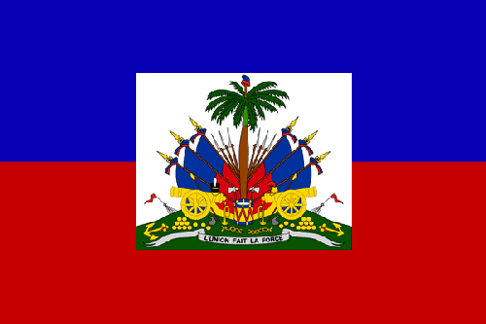Know your Support Teams…

Haiti Partnership Support Team

Support all parishes through “peer reviews”.
Enhance relationships between parish partners through consultation
Encourage sustainable projects
Assist parish to parish communication

Haiti Education Support Team

Work with Hinche catholic education office to enhance catholic education in the Diocese of Hinche
To inform all parishes of school performance scores of their partners’ schools To assist underserved children in Hinche through the shalom fund
To be a resource for parishes to build capacity in their partners’ schools and other needed resources for school accreditation.

Haiti Healthcare Support Team

Assist parish healthcare projects through resource sharing
To develop partnerships with international healthcare organizations for parishes
Work with Hinche Healthcare Commission to ensure sustainability in all healthcare initiatives within Diocese of Hinche
To develop informational sheets and other materials for parishes to use as a resource/reference.
Communication & Media Support Team / OSM

Maintain the Haiti Outreach Website
Distribute an annual paper newsletter on Global Partnership, in particular Haiti Outreach Maintain Diocesan Blog
Assist and maintain database on Global Partnership projects Promote good development practice
Send out the e-newsletters

- of 44

Joining the Commission or a support team
If you’re interested in joining the Commission… You begin by requesting a nomination by one of the standing members. Once you’ve been nominated, the Executive Team will be in contact with you to begin to walk with you in the discernment process.
Following a time of discernment and screening, a Member will begin the mentoring process with a standing member. Our meetings are quarterly with an expectation of every
member attending all 4.
We welcome all that have a passion for Haiti or Global Solidarity to contemplate
joining us.

If you interested in serving on a Support Team….

We welcome you to reach out to the various chairs to begin the discernment process. Serving Christ and the Church through this ministry is both challenging and rewarding. Many Support Team members found themselves on a Team unintentionally, however, their testimonies of life changing in many ways is a testament to Gospel being lived out in global solidarity.

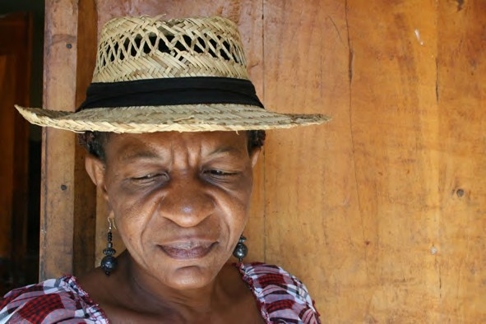

"Pray as though everything depended on God. Work as though everything depended on you."
--St. Augustine

- of 44

Section ii

Parish-based Partnership guidelines

Guidelines and Template for Haiti Twinning (Global Partnership)

Overview and Rationale

As is stated in the Pastoral Plan and, following the example of St. Vincent DePaul, the Church of the Richmond Diocese is committed to sharing faith and resources with a developing country. Recognizing that the Church of Haiti is rich in many gifts but economically poor, our Diocese has respectfully chosen the country of Haiti for this outreach.

As one part of the outreach, each parish in the diocese is encouraged to consider entering into a twinning relationship with a Haitian parish or other entity such as a hospital, school, orphanage or other group.

This twinning relationship should be based on recognition that the many differences between Haiti and Virginia can provide opportunities for growth for each partner, since both possess equal dignity and equal human value.

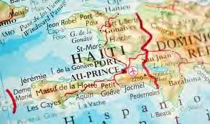Haiti’s long history of struggle for self-determination, its proximity, its poverty, and the powerful spiritual health of its people make Haiti a unique asset to our spiritual development and fulfillment. In understanding Haiti and developing relationships with Haitians, we can better understand ourselves and the interdependence of humankind
- beyond national borders.

But if we are really going to be in solidarity with the Haitian people, it is a lifetime commitment, biblically inspired and based. The American approach of going in with lots of money is not what they need and does not work.
The people of Haiti know what
they need. We need to listen to them and hear what their needs are.

The true measure of success of any global solidarity partnership is not how many wells were dug or clinics held, but whether the capacity of the local community to lead its own development is strengthened. The goal of any partnership should lead to sustainable development, according to the needs of the local Church, and should be designed to reduce the need for outside help.
Haiti catholic conference of bishops, Partners In Mission

- of 44

Objectives of the Twinning Relationship

To develop a sense of solidarity between our sisters and brothers in Haiti and the parishioners in our diocese;

To provide a sense of the universality of Christian community for both partners;

To discover ways in which members of our Virginia communities can share their time and talent with the people of our Haitian twins, and to facilitate that sharing;

To discover ways in which members of our Haitian twins can share their faith and hope with people of Virginia, and to facilitate that sharing;

To be a voice and an advocate for the people of Haiti in the U.S. and to support the actions of the U.S. that will improve the quality of life for Haitians;

To provide sharing of the material wealth of our Virginia twins with our Haitian twins, as we listen to their needs and desires.

Characteristics of a Healthy Twinning Relationship

A process that begins with careful listening to the hopes and concerns of the Haitian people;

Mutual empowerment; an awareness of and concern for the interdependence of the Haitian and U.S. economic and political systems;

Regular communication that involves several persons from both twin communities through e-mail, letters and visits;

In both communities, a broad awareness of and commitment to the twinning relationship and its objectives;

A sense of concern for both the material and spiritual well-being of those in the twinning relationship;

Creative projects that provide vehicles for the mutual sharing of gifts;

Regular visits of members of each twin to the other.

Principles of
Solidarity-based Partnerships

I

Emphasize relationship over resources

II
Practice mutuality & equality

III
seek to give & receive, learn & teach

IV
Work to change unjust systems & structures

V
deepen our faith by experiencing the universal catholic church

crs parish partnership manual &
Haiti Catholic conference of bishops, partner in mission

- of 44

Process for Establishing a Twinning Relationship
The primary responsibility for establishing a twin rest with the Office of Social Ministries and Diocesan Haiti Partnership Team of the Haiti Outreach Commission.

- Decision to Twin/Partner – At any time, after careful discernment, a Diocese of Richmond (DOR) parish or a Diocese of Hinche (DOH) parish can decide it wants to begin a partnership (twinning) relationship. In the case of a DOH parish, a Twinning Questionnaire must be completed by the parish priest and forwarded to the Office of Social Ministries in the DOR. OSM or the Diocesan Haiti Partnership Support Team may also approach parishes directly to encourage them to consider global partnership (twinning).

- Selection of a Twinning Partnership – OSM rep, in collaboration with the Diocesan Haiti Partnership Support Team, reviews the DOR and DOH parishes that have requested twinning partners and decides on a suitable match. This is subject to the approval of both parties.

Note: If DOR parish is small and/or with limited financial resources, this should be made clear to the DOH parish before their decision is made and the question asked, “Do you still wish to twin with this parish, knowing that their ability to provide financial support may be limited?”

Part of the approval process includes a visit to the DOR parish to discuss the twinning relationship and expectations for twinning with the leadership and staff of the DOR parish. The Pastoral Council and Pastor/Pastoral Coordinator of the parish approve the establishment of the twinning relationship and form a Haiti Committee. A Haiti Committee is essential because it is the responsibility of the committee to bring the message of Haiti to the parish and to facilitate the sharing of the relationship between the twinned parishes.

- Establishing Communication – There can be no relationship without communication. It is the foundation of any healthy, successful twinning partnership. The DOR parish, and the DOH parish that has been recommended by OSM, should establish communication, preferably by email, and exchange information, providing a description of themselves for the prospective twinning partner. If the DOH parish does not have email, regular mail can be used but this can be very slow. If the Haitian pastor depends upon a cyber café for email, that may also slow the process. Many DOR twinned parishes have found it beneficial to acquire satellite access for their DOH twin. If no one in the parish speaks Kreyol, and the DOH pastor or leader does not speak English, find someone who speaks French. Most Haitian pastors speak French and you can further communications that way.

- Approval of the Twinning Partnership – After the DOR and DOH parishes have communicated and feel that they are a good fit, the twinning partnership is approved. OSM Director informs the Bishop who writes a congratulatory letter to the newly twinned parish. An announcement is then sent to the Catholic Virginian so the relationship can be celebrated across the diocese. A similar process (Steps 2,3, and 4) should be carried out by the DOH parish.

- Parish Orientation – Since the goal of twinning is to benefit both parishes, not just the few folks who might make up the Haiti Committee, it is important to hold a well-publicized orientation for the entire parish to introduce the new ministry.

[Solidarity] is not a feeling of vague compassion or shallow distress at the misfortunes of so many people, both near and far. On the contrary, it is a firm and persevering determination to commit oneself to the common good; that is to say, to the good of all and of each individual, because we are all really responsible for all. On Social Concern (Sollicitudo rei Socialis. . . ), #38

- of 44

Process for Establishing a Twinning Relationship - continued

- Haitian Pastor Visits – An important beginning in the twinning relationship is the invitation to the DOH pastor or leader to visit the DOR parish. This is important for several reasons:

  - It establishes face-to-face communication between the two parishes and lays the foundation for future communication.
  - Face-to-face dialogue begins to solidify the relationship
  - The Haitian pastor’s presence at parish liturgies, meetings, and special receptions exposes to new Haiti Ministry to parishioners beyond just the Haiti Committee.
- Pilgrimage to Haiti – After the Haitian pastor’s visit, the DOR parish should begin planning a visit to the twinned DOH parish. Consider these trips as pilgrimages. Participants should be personally moved to participate. The travelers should be prepared on a spiritual as well as practical level through a series of pre-trip meetings. A well-formed community travels with the attitude of a pilgrim, open to individual personal transformation. It is important to avoid our natural cultural tendency to find and fix problems, even problems we could not possibly fully understand. These visits are opportunities to explore and share the gifts and needs of each parish. As we journey down a difficult road together, both parishes experience an increase in FAITH and HOPE.

- Cultural Differences concerning Accountability – As communication continues and the relationship develops, specific projects may be undertaken. When this time arrives, it is VERY important to remember the following:

  - Allow the DOH twin to tell the DOR twin what their needs are rather than the DOR twin asserting itself to tell the DOH twin what it needs and how to accomplish it. Listen to the people; they know what they need.
  - If money is involved, follow the Diocesan Financial Accountability Policies whereby the DOH parish can report back to the DOR parish how funds are spent. Be aware that deciding how funds will be spent and reporting back on actual expenditures is a sensitive matter for the DOH parish.
  - There are major cultural differences to be bridged here. Haitians are not used to the planning, budgeting, and reporting requirements that we take for granted. Understand that this is not natural for a DOH parish that rarely finds itself with the financial resources to look past next week (or even tomorrow). Haitians consider gifts, even money, to be freely given with no strings attached. Also, Americans expect funds given for a purpose to be used for that purpose – not diverted to something different. If Haitians are asked to account for funds donated for a project, they may feel that the American partner doesn’t trust them. This quickly becomes a matter of personal dignity, nevertheless, certain Diocesan standards must be followed by all partners.

  - The DOR parish must communicate, as sensitively as possible, that parishioners who contribute funds care deeply about the project for which the funds were donated, and they cannot continue to contribute if they see no financial accountability. Experience suggests it is best to address this issue early in the twinning relationship and create clear expectations.

"The proof of love is in the works. Where love exists, it works great things. But when it ceases to act, it ceases to exist."
--Pope St. Gregory the Great

- of 44

Process for Establishing a Twinning Relationship - continued

- Basic Projects – There is often a natural progression in the types of projects worked on in a twinning relationship. This may depend on the financial resources of the DOR parish:

  - Haitian parishes are materially impoverished and often do not have the basic infrastructure needed to adequately sustain parish life. There may be no rectory or church. If buildings exist, they may be in disrepair or without electricity. Depending on the condition of the parish, the pastor may identify these basic needs as priorities.

  - Haitians value education and healthcare. Often, the next level of need will be a school, clinic, or water project to provide potable water for people in the area. DOR encourages sustainable projects and will assist upon request both partners to develop projects that don’t create dependency or reduce the dignity of the Haitian people.

- Sustainable Development Projects – Once basic needs are being met, both parishes can turn to more sustainable projects. “Sustainable” projects are those that can sustain themselves both economically (without ongoing external financial support) and environmentally (without doing harm to the environment). Sustainable projects help the people of Haiti provide for themselves the basic necessities of life without having to depend on the charity of others. A twinning strategy that includes this type of thinking respects the inherent dignity of our Haitian brothers and sisters who currently live in day-to-day survival mode.

Some examples: Heifer Project, businesses built around computers, sewing machines, baking equipment, or health care and training for jobs already in existence. FONKOZE micro-finance training and micro-loan programs as well as DOH Caritas programs are useful assets.

Programs to improve agricultural practices or to promote reforestation can also be examples of sustainable development projects.

NOTE: The DOR parish and Haitians themselves ultimately want Haitians to be able to provide for themselves. Even in the early stages of twinning, when parishes may be focused on basic needs, it is important to keep the idea of sustainability in mind. The Haiti Outreach Commission’s Haiti Partnership Support Team can be a guide and resource to parishes as they begin to twin and throughout the twinning relationship.

The true measure of success of any global solidarity partnership is not how many wells were dug or clinics held, but whether the capacity of the local community to lead its own development is strengthened. The goal of any partnership should lead to sustainable development, according to the needs of the local Church, and should be designed to reduce the need for outside help.
Haiti catholic conference of bishops, Partners In Mission

- of 44

After twinning begins:

- You will be included in the Diocesan Haiti email list and mailing list
- You may continue to utilize the Diocesan Office of Social Ministries, regional twinning representatives from the Diocesan Parish Partnership Support Team, or any other Support Team that is needed, and other parishes in the area that have twinning programs for continued support and resourcing.
- Take advantage of information contained in the Haiti Outreach website.
- Remember that you are NOT alone! You have a network of support!
- Whenever possible, raise awareness of the reality of Haiti and encourage people from other parishes that are not currently twinned to consider twinning. Refer interested parties to the Diocesan Haiti Partnership Support Team.
if one member of Christ’s body suffers, all suffer. if one member is honored, all rejoice.
1 Corinthians
12:12-26

Dynamics of Groups Already Twinned

•Co-twinning: Decisions considering co-twinning with another Virginia parish are exceptions to the guidelines and are processed through the Office of Ministries.
•Changing twins is also an exception to the guidelines and is processed through the Office of Social Ministries from the DOR.
•All fund raising for your Haiti Twin should be limited to your parish, unless approved by the Office of Social Ministries.
•All Teams, committees, foundations, or boards under the Haiti Commission must receive approval from the Director of OSM in order to solicit funds from parishes in the Diocese.

All groups or individuals in the diocese planning trips to Haiti should notify OSM. In addition to parish trips and Diocesan Retreat trips, this would include medical trips, college trips, and trips connected with the Haiti Commission’s Foundations or Committees.

Peer Review Policy (New)

Overview
All parishes are required to submit all new projects or initiatives to the Haiti Partnership Support Team for a Peer Review. Please note that the review will take approximately 2 months, so please plan accordingly. Following the Peer Review, you will receive a formal response that will include input and resources from the HPST. You are encouraged to utilize the information in collaboration with your Haitian Partner to increase capacity within your project.
However, please note that utilizing the HPST input/recommendations are optional and dependent on the Parish Priest. However, OSM’s rep reserves the right to follow-up with the parish priest on all projects. Forms and additional information are available on the Haiti Outreach Website.

Send to OSM the peer review forms. Note: qualifications below

Parish will be requested to fill out an evaluation on the resources received from the Parish Partnership Support Team.

OSM will send the official review to the Parish & facilitate any follow up that’s needed.
Twinning partners decide on the project with the Haitian partner taking the lead.

Begin planning the project and document the details.
Parish Partnership Support Team will review the project.

- of 44

Peer Review Policy continued

What to expect from the Peer Review Process?

You will receive an official response from the PPST (expect it to take 2 months or less) and a follow up evaluation on the input your ministry has received following the review process.

You can request additional information or additional services through the chair of the PPST.
- Please note, that compliance to PPST’s recommendations are not mandatory. Our goal is NOT to interfere with the Partnership relationship, but rather to assist and gain from the Peer Review process.

This Peer Review Process is required for all new projects. New projects can be defined by two factors - nature of the project and expenses of the project.
  - Nature: we ask all development projects (no matter the size) be submitted for a Peer Review
  - Expense: If an project exceeds $ 5,000.00, then a Parish is required to submit it for a Peer Review.

Some Examples:

If your Haiti Committee decides to buy new bowls for your Partner’s parish school, this would NOT be considered a new project, therefore is not required for Peer Review

If your Haiti committee decides to drastically upgrade your Partner’s water system, since this becomes a sustainability and development issue, then the HPST would request for you to have it reviewed.

If you are unsure if a particular project needs to go through the Peer Review process, then please email the Director of Global Ministries at jmyers@richmondiocese.org for assistance.

Why is this required?

Parish Partnership Support Team with the Hinche Commission will review as peers the project for 3 main reasons

  - To offer a certain level of support through input, referrals to relevant organizations, and networking between parishes.
  - To learn from your projects and ideas in order to highlight and copy on a Diocesan level.
  - To enhance the Diocese of Hinche’s input and voice within DOR’s Haiti Outreach.

For Peer Review forms visit the
Haiti Outreach Website on the OSM website.

Caritas Hinche Production Farm Hinche Haiti

- of 44

Section iii
financial policies & procedures

Policy for Fiscal Accountability

Introduction

As part of the Diocese of Richmond Haiti Twinning Ministry there are many parishes as well as diocesan committees and boards which send funds to Haiti on an ongoing basis. A reporting system accounting for the use of these funds is necessary for fiscal accountability and transparency purposes.

It is important that the Diocese of Richmond receive reports from their partners in Haiti on funds that are sent. This practice is expected and routine in the American culture.

The Diocese of Richmond recognizes that there are cultural differences between the two countries in their fundamental understanding of money and it recognizes that this policy will affect both the Diocese of Richmond and the Diocese of Hinche. Therefore, the Diocese of Richmond is working in a collaborative manner to implement the policy on fiscal accountability with the Diocese of Hinche.

Additionally, the Diocese of Richmond and the Diocese of Hinche must have an accurate reporting of how much money is being sent to Haiti during a fiscal year. Therefore, the Diocese of Richmond Haiti twinning parishes will be required to provide this information in the end of the year parish financial report (Form #6) with all other reports that were used throughout the year to the Diocese of Richmond’s Office of Social Ministries.

Policy
- When funds are sent to Haitian partners from the Diocese of Richmond parishes, committees or boards for the purpose of implementing a project, the following procedure and reporting will be followed:

The Haitian partner will submit a project proposal (Financial Report Form #1) which would include:
  - A description of the project
  - A cost estimate
  - A time frame for completion of the project
The Richmond partner will review the proposal and decide whether to fund the project. The Richmond partner will communicate the decision to the Haiti partner.
The Haiti partner will provide the Richmond partner with regular reports based on a mutually agreed upon time frame during the project period (Financial Report Form # 3).

Reports must be submitted, received and reviewed prior to the transfer of additional funds for the project. The report will include:
  - A description of the project activities during the reporting period.
  - The prior reporting period’s expenditures
  - Receipts for expenditures or use Form #7
  - Description of any obstacles encountered during the reporting period and any anticipated obstacles or changes in the plan
  - Anticipated expenditures for the coming period
The Diocese of Richmond partner will review the report prior to the transfer of funds.

- of 44

Policy for Fiscal Accountability Continued
Upon completion of the project a final report will be submitted by the Haiti partner to the Richmond partner (Financial Report Form # 4). This report will include:
- A summary of the project
- A summary of expenditures
- Final receipts for expenditures
- A final budget report including the projected expenditures and the actual expenditures with a description of the reconciliation of the budget if there is a discrepancy between the anticipated budget and actual expenditures

The Diocese of Richmond partner will assist the Haiti partner with any technical assistance needed to complete the fiscal accountability reporting policy.

- When funds are sent to Haiti partners from the Diocese of Richmond parishes, committees or boards for the purpose of funding ongoing recurring costs - such as salaries (teachers, nurses, etc) or food programs, the following procedure and reporting will be followed:

The Haitian partner and Richmond partner should have an agreement in writing concerning the recurring cost. The agreement should include the purpose of the use of the funds, the amount of the funds and the frequency of the payment (Financial Report Form #2). For salaries, the agreement should include arrangements to maintain monthly payrolls initialed by salary recipients. (Financial Report Form # 5).

The partners should agree on the procedure and frequency to report how the funds are used (Financial Report Form # 3).

- When funds are sent to Haiti partners from the Diocese of Richmond parishes, committees or boards for the purpose of providing discretionary funds to be used for unexpected expenses and at the discretion of the Haitian priest, the following procedure and reporting will be followed:

It is the responsibility of the Richmond and Haitian partners to agree on the policy of the disbursement and use of discretionary funds.

It is asked that there be a reporting system of how the discretionary funds have been used (Financial Report Form # 4).

No funds collected from the Richmond partners that are designated for a specific purpose can be used as discretionary funds. All donations given for specific projects and/ or purpose must be used for the intended purpose. For example, money raised specifically for a school, etc. should not be used for discretionary items. On the other hand, if the Richmond partner has a monthly undesignated collection or a collection taken up while the priest is visiting; this can be used for discretionary purposes.

- Each Diocese of Richmond Parish which has a twinning relationship in Haiti will adhere to the following fiscal accountability reporting (Financial Report Form #6 in addition to all other Forms used in the Partnership throughout the Fiscal year)

Each parish which has a twinning relationship with Haiti will include in its end of the year financial report to the diocese:
  - The total amount of money it sent to Haiti during the fiscal year
  - An itemization of the funds sent during the fiscal year which would include the amount and the purpose of the funds.
  - All reports that were used throughout the year with supporting documentation (receipts).
The Diocese of Richmond Haiti Ministry will compile the information and present an annual report to the Bishop of Richmond and the Bishop of Hinche. The report will include the total amount of money sent to Haiti and a further break down categorizing the purpose of the funds. (i.e. schools water projects, health care projects).

- of 44

OSM can assist parish volunteers with completing financial reports upon request.
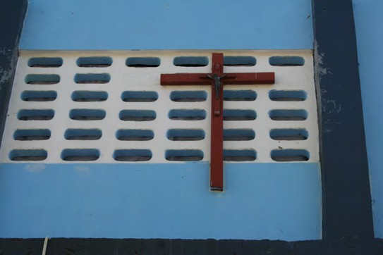Key Points to remember

Parish-based twinning committees should take a proactive role in engaging the pastor and parish leadership

The parish priest and his appointed parish leadership are responsible to establish the twinning committees’ annual budgeting process guidelines.

All Financial Report Forms are to be submitted to OSM with the end of the year financial report (Financial Report Form #6)

All Financial Report Forms are due by August 15th.

Financial Review Team will review all forms submitted for the fiscal year. If there’s additional information that is needed for the review process, the OSM will send an official request to the parish for the additional information.

- 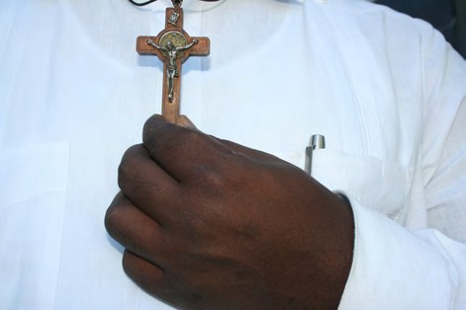of 44
Please note: a new form has been developed to assist with expense documentation for items that our Haiti Partners
are unable to get receipts for. (Financial Form 7)

Section iv
traveling to Haiti

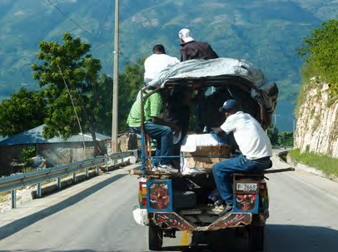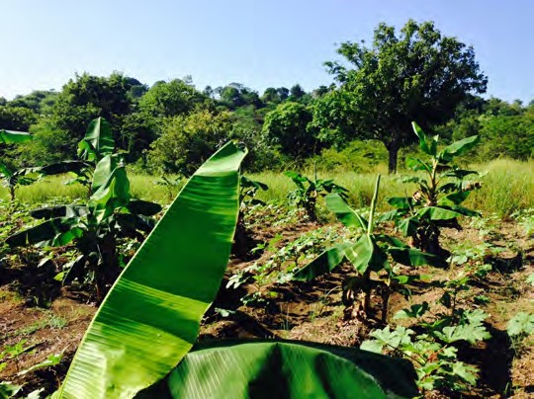3 Easy Steps

1

Inform OSM and your priest and fill out the Emergency Information Form found in the Trip Orientation Manual.

Trip Orientation Manual can be found on our Haiti Outreach website.

2

Schedule a Pilgrimage (Trip) Orientation with your team. OSM or the Haiti Commission’s help may be elicited.
IMPORTANT
Reminder
All travelers working with children are required to attend a VIRTUS training and complete the diocesan Volunteer Background Screening as stated in the Diocesan Child Protection Policy.

3

Begin praying for the success & a fruitful conversion during your trip.

30 of 44

Emergency Contact Procedure for Delegations to Haiti from the Diocese of Richmond

The Haitian Ministries of the Catholic Diocese of Richmond has developed the following procedure to ensure that Parish Delegations in Haiti may be in contact with their parishes should a natural disaster or crisis occur during their travel. We ask that all parish delegations implement this simple procedure so that parishes and family members can maintain a minimum level of communication through natural or other disasters.

For Travelers:
- Register your trip and all participants with the US Embassy no less than one week (7 days) prior to leaving the United States.
  - Register online at https://step.state.gov/
  - Compile a list of all travelers, their passport numbers, and contact information in Haiti and an emergency contact in the United States
    - Fax a list of all travelers to the American Citizens Services (ACS) at
(509)-2-229-8027
    - Leave the list with an identified Emergency Contact within your parish’s ministry along with a detailed itinerary and contact information of your partners in Haiti.
    - Email the list, itinerary, and name/contact information of the Emergency Contact at your parish to the Office of Social Ministries: osm@richmonddiocese.org

In the Event of an Emergency: Travelers:
- In the event of an Emergency, travelers from the Diocese of Richmond in Haiti should contact ACS of the US Consulate as soon as possible.
  - Call (509) 2-229-8000 (509-2229-8122 - after hours) to be connected with the US Marine Guard who will connect you with the US Embassy Duty Officer
  - Provide ACS with information on your location and safety.
  - Follow all instructions provided by ACS.
Parish Emergency Contact:
- In the event of an Emergency, contact ACS who will provide known information or work to secure information on your group in Haiti.
  - Call one of the following numbers: i. (509) 2-229-8942
ii.(509) 2-229-8089
iii.(509) 2-229-8322
iv. (509) 2-229-8672
  - Provide the full name, passport information, contact information (if known), address or approximate location and your contact information.

The Embassy task force will relay information on the safety of your group as soon as possible. OSM Staff will work with the Emergency Contact at your Parish to gather information on your safety to relay to the Parish.

A friend who is far away is sometimes much nearer than one who is at hand. Is not the mountain far more awe-inspiring and more clearly visible to
one passing through the valley than to those who inhabit the mountain?
Khalil Gibran Lebanese Artist and Poet

31 of 44

Section v
youth travel guidelines

The Diocese of Richmond Policy for Youth Travel to Haiti

In the event of a trip to Haiti sponsored by a parish, the diocese or a diocesan group/ organization, youth under the age of 18 may participate under the following guidelines:
- Youth ages 15 to under 18 must be accompanied by one of the following:
    - A parent.
    - A designated guardian appointed by the parent through a notarized statement.
    - Chaperones from the parish or diocesan group/organization in the ratio of 4 to one.

- Youth under the age of 15 must be accompanied by a parent.
- The parent or legal guardian must provide the following diocesan written consent forms:
- Traveler information and Parent/Guardian Consent Form and

- Diocese of Richmond Youth Traveler Assumption of Risks and Release Agreement.

- All youth travelers must have international medical insurance coverage including evacuation. If the individual’s insurance policy does not provide coverage, it may be purchased through MEDEX.
- All persons participating in trips to Haiti must follow all guidelines of the Diocesan Safe Environment
Regulations Policy which includes background screening
nobody is so poor that he has nothing to give, and nobody is so rich that he has nothing to receive.
pope john paul II

and VIRTUS training for those 18 and older. Please access a copy of these guidelines on the diocesan web site http://richmonddiocese.org/child_protection_virtus/ All youth and guardians/chaperones must participate in the pre-orientation session prior to the trip to Haiti.
- The adult trip leaders must provide the Office of Social Ministries copies of the Traveler Information and Parent/ Guardian Consent forms, Diocese of Richmond Youth Traveler Assumption of Risks and Release Agreements, a copy of the travel itinerary with contact numbers in Haiti and a roster of trip participants.
- Director of Office of Social Ministries reserves the right to make a final determination concerning the participation of youth traveling to Haiti.

The Catholic Diocese of Richmond is committed to ensuring that diocesan institutions and ministries provide a safe and nurturing environment for children, young people and vulnerable individuals.
The mission of the diocese Safe Environment Program is to create a safe environment incorporating the standards as outlined in the Charter for the Protection of Children and Young People.

33 of 44

Section vi
diocesan partnership support vehicle

Haiti Ministry Commission
Diocesan Policy for the use of the Diocesan Vehicle
The diocesan vehicle in Haiti is available for use for the Diocese of Richmond parish twinning program.

The Lead Staff for Haiti Ministry within the Office of Social Ministries (hereafter “the OSM Staff Person”) has the following responsibilities:
  - schedules the use of the vehicle;
  - communicates the schedule to the driver and the Diocese of Richmond’s Contracted Accountant;
  - remits payment for the upkeep and maintenance of the vehicle and for employee costs through the Diocese of Richmond’s Contracted Accountant; and
  - makes final decisions regarding the use and oversight of the vehicle.

The following policies guide the use of the vehicle by groups and/or individuals:
- Scheduling, fees, and Payments:
A parish group or individual will contact the OSM Staff Person to schedule the use of the vehicle. The OSM Staff Person is the only person authorized to schedule the use of the vehicle.
There will be at least 2 days between scheduled trips of five days or more so that the driver has adequate rest between trips.
Check availability of the Support Vehicle on the Haiti Outreach Website
Parish twinning committees and diocesan committees and boards have first priority for the scheduling of the vehicle. Individuals must take second priority.
The vehicle schedule will be available for scheduling up to one year prior to the time a trip is to be taken. The use of the vehicle is for groups and business associated with the Diocese of Richmond.
Individuals who want to use the vehicle are limited to one week unless otherwise determined by the OSM Staff Person.
The cost to use the vehicle is $150 each day:
Upon scheduling the vehicle with the OSM Staff Person a non refundable,
$100.00 deposit must be paid by each group/individual who schedules its use. The deposit will be $100.00 for each trip. Prior to receipt of the fee, the reservation will be considered as an “on hold” status. The fee must be received within two weeks after scheduling the vehicle.
A signed copy of the Vehicle Use Policy must be returned with the
$100.00 deposit. The policy can be down loaded from the web site or attained through the OSM Staff Person (osm@richmonddiocese.org).
At least 7 days before departure, groups/individuals who have reserved the vehicle will pay the remainder of the total due for use of the vehicle (e.g. for a 5 day trip, the total fee for the vehicle will be $750.00 – the $100.00 nonrefundable deposit will be paid 2 weeks after scheduling the vehicle. The remaining $650.00 will be paid no later than 7 days before departure).
All payments must be made payable to:
Diocese of Richmond 7800 Carousel Lane
Richmond, VA 23294 Memo: Haiti Vehicle

- of 44

Upon receipt of the deposit and signed Jeep Use Policy, the reservation will be finalized. A copy of the vehicle schedule with the group’s reservation will be communicated to the driver. The group’s trip will be again communicated to the driver at least one week prior to the trip.
A “Vehicle Fees and Payments” summary will be emailed to you upon receipt of your signed agreement by the OSM Staff Person. This summary will indicate the final due date for all payments related to the use of the Diocesan Vehicle in Haiti.

- Driver and Vehicle :
The driver of the diocesan vehicle will be responsible for informal, incidental interpreting for groups traveling to Haiti and using the diocesan vehicle. Examples of incidental interpretation include but are not limited to:
Ordering food and communicating with the wait staff at a restaurant Communicating with the staff of a guest house
Negotiating the purchase of items in a store or a place of business
Informal communication with Haitians such as simple dialogue at a dinner table Sightseeing and simple tours of local Haitian attractions.
Touring of a Haitian project such as a clinic, school, agricultural project

The Diocese of Richmond group will enter into a mutually acceptable agreement with the driver at the onset of the trip for any interpreting services other than informal, incidental interpreting using the following guidelines:
For availability of intermittent but ongoing interpreting a fee of $40.00 per day is expected (payable in cash directly to the driver of the Diocesan Vehicle).

For instances where the group requires more extensive interpreting services, but not in an intermittent and ongoing way during the trip (and thus not paying a fee of $40.00 per day), a fee of $15.00 per hour or any part of an hour will be paid. Examples of incidences qualifying for these interpreting services include but are not limited to:
Meetings between the American group and Haitian individuals, groups or organizations Parish business such as interpreting while doing work in a clinic or in a school

Groups/individuals may give the driver a tip at their discretion. A maximum tip of 20% of the $35.00 per diem that the driver will receive for his services is suggested. If the group or individual feels motivated to give more than this amount it is suggested that they make a contribution to the Diocesan vehicle fund. The purpose of the fund is to support the driver’s salary, to provide vehicle upkeep and to plan for the purchase of a new vehicle.
A daily itinerary for the entire time in Haiti must be given to the driver at the start of the first day of the trip. Each group must fill the gas tank at the conclusion of their trip. Every group will start out with a full tank of gas. The group is responsible to pay for gas at the pump at the time of fueling the vehicle.
Each group is responsible for the food and lodging of the driver(s).
The drinking of alcohol in the vehicle (by either the driver or passengers) is not permitted at any time.
The driver’s on-duty time (including driving, translating and other activities) is eight (8) hours in a day. Groups from the US will be responsible to pay the driver $15.00 per hour for each additional hour the driver works in any given day.
The driver is not expected to drive after dark.

- of 44

Section vi
child safety guidelines

Virtus Policy
Please note that all volunteers or committee members that travel to Haiti must attend a VIRTUS training and complete the diocesan Volunteer Background Screening. For additional information, please go to the Diocese of Richmond’s Safe Environment page at http://richmonddiocese.org/child_protection_virtus/

Photo Release Policy

Office of Social Ministries requires that all photos or other visual media of children used for twinning ministry promotion, soliciting for funds, or used in any public format for the ministry should have a photo release form filed at the parish. A digital copy of the form can be found at the Haiti outreach website

Volunteer & Donor Restrictions
Office of Social Ministries ask all parishes, Diocesan teams, committees, boards, and foundations to ensure Child Safety by developing policies that will limit direct contact of the underage recipients with donors or sponsors. If you need additional assistance in developing these policies, please contact OSM at osm@richmonddiocese.org

"A person's a person, no matter how small.” Dr. Seuss

38 of 44

Section vii
additional resources

Outside Organizations Catholic Relief Services Parish Partnership Manual
OSM and the Haiti Outreach Commission encourage all parishes to incorporate and utilize the CRS Parish Partnership Manual within their partnership ministries. For a copy of the Manual visit http://uspartners.crs.org/wp-content/uploads/2014/05/manual-for-partnerships.pdf
Principles of Solidarity-based Partnerships

I
Emphasize relationship over resources

II
Practice mutuality & equality

III
Seek to give & receive, learn & teach

IV
Work to change unjust systems & structures

V
Deepen our faith by experiencing the universal catholic church
CRS Parish Partnership Manual &
Haiti Catholic Conference of Bishops, Partner in Mission
OSM and the Haiti Outreach Commission will offer a resource to assist parishes choosing potential partnership with outside organizations.

Beginning September 2014, OSM with the Haiti Outreach Commission will begin compiling a list of organizations that it feels agree with the principles of DOR’s Haiti Outreach and follow international standards. All parishes are encouraged to utilize this Suggested Organization List when picking projects or organizations to partner with that are facilitated outside the Catholic Church. All partnerships are determined by the parish priest, therefore, the Suggested Organization List is only a resources and tool for parishes to make well informed decisions. Please note: that any organization seeking support from the Diocese will have to go through the Diocesan Approval for Organizations Seeking Diocesan Promotion process.

What questions should a parish ask themselves before partnering with an organization? There are a list of questions that all parishes should try to answer before supporting or partnering with an outside organization.

Principle Criteria to determine whether or not to partner or promote an organization.
- Does the organization exhibit consistency of message and actions with the Church’s social and moral teaching?
- Does the organization exhibit a consistent message and
actions that support the vision and direction of the Catholic Diocese of Richmond and Haiti Outreach?

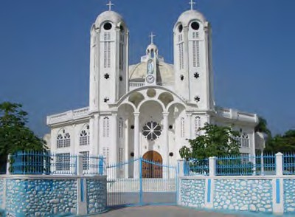Standards
- Are the financial practices inline with international development standards?
- Are certain protection policies in place to ensure the
safety of children and vulnerable populations?
- Are the projects sustainable and Haitian led?
- How does your parish’s Haitian partner feel about the organization?
- Are there other organizations that would be a better fit
or more effective for your parish?

If you need additional information or assistance, please contact OSM at osm@richmonddiocese.org

40 of 44

Books

Aristide, Jean-Betrand. Eyes of the Heart. Globalization and its effect on Third World Countries. Monroe, Maine: Common Courage Press, 2000.

Bell, Beverly. Walking on Fire: Haitian Women's Stories of Survival and Resistance. Ithaca and London: Cornell University Press, 2001.

Farmer, Paul. The Uses of Haiti. Maine: Common Courage Press, Rev. 2003

Fatton, Robert Jr. Haiti's Predatory Republic: The Unending Transition to Democracy. Boulder: Lynne Rienner Publisher. 2002

Kidder, Tracy. Mountains Beyond Mountains: Healing the World: The Quest of Dr. Paul Farmer Random House, 2003

Paris, Barry. Song of Haiti. The lives of Dr. Larry & Gwen Mellon at the Albert Schweitzer Hospital of Deschapelles. Public Affairs: 2000

Randall Robinson. An Unbroken Agony: Haiti, From Revolution to the Kidnapping of a President.

Advocacy
Catholic Relief Services: www.crs.org/Haiti/

Culture and language
Haitian Studies Association: www.haitianstudies.umb.edu/aboutus.html Indiana University Creole Institute: www.indiana.edu/~creole/ Windows on Haiti: www.windowsonhaiti.com/

Educational Materials
Educa Vision: www.educavision.com

Government
U.S. Embassy in Haiti: portauprince.usembassy.gov

Twinning
The Parish Twinning Program of the Americas: www.parishprogram.org

41of 44

For assistance, please contact Office of Social Ministries

osm@richmonddiocese.org

804-622-5206

